Two hundred “Two Minute” Physics Demonstrations and Visualizations with Common Objects

For All Education Levels and Classroom Conditions

Ed van den Berg

Vrije Universiteit

Amsterdam, Netherlands

# Two hundred “Two Minute” Physics[1] Demonstrations and Visualizations[2]

# Abstract and introduction

Suppose you are suddenly assigned to a bare classroom far from the location of your nice laboratory classroom, or you have to substitute in another class without preparation? Or you are teaching at a school without facilities? How can you still have a clear and exciting lesson? This booklet presents a collection of small and quick demonstrations, which require no equipment beyond what is present in a bare classroom (chalk, chairs, students, books, paper, student bags and common contents). The collection can be easily expanded. The nature of the demos is varied, some are to prove something, but most are to illustrate, visualize, or simulate. A few role-plays are included for when students are restless, cold, or sleepy or for when their instructor needs a kick to get into a better mood after a late night of checking students’ papers.

Rules for demonstrations are of course:

* Visibility for all;
* A clear learning objective, even if the demo is intended for entertainment, there must be something that can be learned;
* Taking into account typical student conceptions and using these productively in the discussion;
* Involvement, get students involved in predicting, observing, and explaining. There can be teacher questions or tasks which students answer individually in their notebooks or in pairs or groups in order to really force *minds-on*;
* Emphasize the main points and leave out unnecessary details or discuss the details after the main points have been made.

This booklet provides mostly just bare ideas for demo’s and visualizations. For more extensive instructional tips and good questions to ask I refer to Liem’s Invitations to Science Inquiry (1987), a pdf can be found quickly with Google.

One could wonder whether these demonstrations and visualizations are still needed now that we have YouTube. I think that real demonstrations are still different from watching TV. It is important that students learn to recognize the physics phenomena in their own environment and realize that they themselves could actually perform the experiments.

Just to exercise our creativity, let’s take a glass of water. We can use that to demonstrate: properties of liquids, that the water level is always horizontal whichever way the glass is turned or tilted, adhesion (water higher on the sides), cohesion (the glass can be filled higher than the rim without overflowing), condensation (breathe on the side of the glass), sinking/floating (put something in the water), buoyancy, refraction (put a pencil in), a lens (put your finger in and it appears thicker), concentric water waves (dip in a pencil), sloshing (shake with resonance frequency), sounds dependent on water level (tick against the glass with a coin). One can easily get over 30 different demo’s just with a glass of water (Berg, 2020). Take any other object such as a chair or a table and you get many more demonstrations and visualizations. Ehrlig (1994) published 34 experiments with a plastic ruler. So, you yourself can add many experiments to this list. There are some standard objects that should always be in the bag or pocket of a physics teacher: a candle, matches or a lighter, two small stones of different sizes, a balloon that can be blown up, a ruler, some different coins, straws, a rubber band, a slinky, some strings, a scissor, and a laser pointer or flashlight.

Now let us get on with it. Here are the demo’s…..

Two hundred “Two Minute” Physics Demonstrations and Visualizations 2

Abstract and introduction 2

MECHANICS 9

1. Free fall and independence of mass 9

2. Can we accelerate our hands more than g? Proof it! 9

3. Fall and Air Drag 9

4. Paper baskets 9

5. Flying is playing with air resistance 10

6. Kinematics 10

7. Relative motion 10

8. Action versus reaction visualization exercise 11

9. Linear inertia 1, Newton’s First Law 11

10. Linear inertia 2 12

11. Linear inertia 3 12

12. Rotational inertia 12

13. Rotational inertia 2 12

14. Rotational inertia 3 12

15. Circular motion 1 13

16. Circular motion 2 13

17. Circular motion 3 13

18. Projectile motion 1 13

19. Projectile motion 2 13

20. Projectile motion, relative motion 14

21. Air pressure 14

22. Static and kinetic friction and center of mass 14

23. Static and kinetic friction 15

24. Friction 1 (Leisink, 2006) 15

25. Friction 2 15

26. Friction and heat 15

27. Friction and normal force 1 15

28. Friction and normal force 2 15

29. Friction and inclined plane 16

30. Difference between static and kinetic friction 16

31. Strength of profiles 16

32. Center of mass 1 16

33. Center of mass 2 17

34. Center of mass 3 17

35. Center of mass 4 17

36. Rotation, center of mass, stability 17

37. Pressure and surface area 17

38. Simple machines 17

39. Torque 18

40. Torque and distance from axis 18

41. Moment of force 1 18

42. Moment of force 2 18

43. Springs parallel and in series 18

44. Tensile and shear stress 18

45. Collisions and preventing damage 18

46. Breaking or not? 19

47. Bernoulli 1 19

48. Bernoulli 2 20

49. Bernouilli 3 20

50. Energy conversions 20

51. Work and kinetic energy 20

52. Asymmetry in properties, friction of hair 21

LIQUIDS AND AIR 22

1. Liquids: Anybody with nail polish, coca cola, or something else that is liquid? 22

2. Floating and sinking 22

3. Floating and sinking 22

4. Adhesion in a glass of water 22

5. Adhesion on a penny 22

6. Adhesion and crumbs 22

7. Capillarity 1 23

8. Capillarity 2 23

9. Cohesion 23

10. Adhesion and cohesion 23

11. Floating on convex and concave surfaces 24

12. Chromatography 24

13. Air pressure and liquids 24

14. Air bubbles 24

15. Transferring air bubbles under water 24

16. Air occupies space 24

17. Carbonated drinks 24

18. Pressure, bubbles, straws 25

19. Atmospheric and liquid pressure, cohesion and surface tension 25

20. Projectile motion with water 25

21. Liquid pressure 25

22. Liquid pressure and free fall 25

23. Emptying bottles 26

24. Emptying beakers/glasses 26

25. Liquid resistance 26

26. Liquid versus vapor balance, relative humidity, saturation, open versus closed container: 26

27. Bernouilli and a candle flame 26

28. Lift water by blowing 27

ELECTRICITY 28

1. Static electricity and textile, ballpoint pen and paper 28

2. Static electricity and balloons 28

3. Salt and pepper 28

4. Straws 28

5. Coulomb’s Law 28

6. Water molecules are dipoles 29

7. Flow of electricity compared to water 29

8. Conductors and insulators 29

9. Circuits 29

10. Role-play to distinguish between electric current, power, and voltage 29

MAGNETISM, ELECTRO-MAGNETIC INDUCTION 30

1. Properties of magnets 30

2. Magnetizing a needle 30

3. Magnet in mobile phone holder 30

4. Compass 30

5. Generator 1 30

6. Generator 2 30

7. Electric motor 30

8. Visualizing magnetic fields in coils 31

9. Visualizing magnetic fields around wires 31

10. Visualizing the Lorentz force 31

11. Lorentz force in a coil 31

12. Magnetic brake 31

HEAT AND TEMPERATURE, PHASES 32

1. Hand as thermometer 32

2. Adding temperatures or not? Intensive versus extensive variables 32

3. Heat and friction 32

4. Conduction 32

5. Convection 32

6. Roleplay: Melting-boiling-condensing-solidifying 32

7. Melting and plate tectonics 33

8. Cooling effect of narrow nozzles (Hewitt, 2015) 33

9. Evaporation and cooling 34

10. Evaporation/condensation 34

11. Evaporation and diffusion 34

12. Sublimation 34

13. Energy transport: conduction, convection, evaporation, radiation 34

14. Keeping water warm 35

15. Cooling water quickly 35

16. Conduction, convection, radiation with a match or lighter 35

17. Describing candles and flames and formulating questions 35

18. Candle, what is it that burns? 35

19. Exploring the temperature pattern of the flame 1 36

20. Exploring the temperature pattern of the flame 2 36

21. Products of candle flames 36

22. Preventing oxygen to reach the candle flame 36

23. Rising water 36

24. Convection around candle flames 36

25. Convection: Tea bag rocket 36

26. Money surviving the flames 37

EARTH SCIENCE 38

1. Visualizing revolution and rotation of the Earth 38

2. Visualizing Rotation of the Sun 38

3. Visualizing Movement of Moon 38

4. Visualizing rotation of the Moon 38

5. Visualizing parallax for distance measurement 38

6. Apparent movement of the stars throughout the year 39

7. Comet 39

8. Visualizing plate tectonics, collisions between thin ocean plates 39

9. Visualizing plate tectonics, collision between a thin ocean plate and a thick continental plate 39

10. Visualizing plate tectonics with islands, accretion 39

11. Visualizing plate tectonics, collision between two thick continental plates 39

OSCILLATIONS AND WAVES 40

1. Pendulum, period, natural frequencies 40

2. What affects periods 40

3. Rulers and periods 40

4. Tension and pitch 40

5. Resonance 1 40

6. Resonance 2 41

7. In phase and out of phase 41

8. Collisions of coins 41

9. Wave as propagation of a disturbance 41

10. Other 41

11. Beats, Moiré patterns 41

SOUND 43

1. Natural sounds, frequencies, timbre 43

2. Pitch and length 1 43

3. Pitch and length 2 43

4. Standing waves in a PVC tube open and closed 43

5. PVC pipe length and pitch 43

6. Measuring pitch with a telephone 43

7. Mobile phone and graphing sound waves 43

8. Resonance 1 44

9. Resonance 3 44

10. vsound = f λ but velocity is independent of frequency and wave length! 44

11. Doppler simulation 44

LIGHT 45

1. Straight line propagation of light 45

2. White light and colors 46

3. Producing colors 46

4. Color subtraction 46

5. Color addition 47

6. Reflection 47

7. FOTOSnell’s Reflection Law 1 48

8. Snell’s reflection Law 2 48

9. Snell’s reflection Law 3 48

10. Refraction 1 48

11. Refraction 2 49

12. Refraction 3 (Czech contribution to Physics on Stage, Nugent et al, 2010) 49

13. Bright versus dark background 49

14. Pupil, diaphragm 49

15. Reflection and transmission 1 50

16. Reflection and transmission 2 50

17. Accommodation of the eye 50

18. Depth of field 50

19. Lenses 50

20. Narrow slit diffraction or refraction? 50

21. Mouche volante 50

22. Parallax 51

23. Dominance of one eye 51

24. Seeing depth 1 51

25. Seeing depth 2 52

26. Blind spot 52

27. Center and sides of retina, peripheral vision 52

28. Optical illusions 52

29. Diffraction 52

30. OHP 52

31. Minnaert 52

32. Other 53

MODERN PHYSICS 54

1. Flames and colors 54

2. Particle-wave duality 54

3. Double slit, role play of how it is NOT 54

4. Mass numbers of the elements 54

5. Rutherford experiment 55

6. Big bang and Hubble 1 55

7. Big bang and Hubble 2 55

8. Big bang and Hubble 2 55

9. Hidden dimensions in string theory 55

LITERATURE 56

# MECHANICS

## Free fall and independence of mass

Break a piece of chalk into a small and a big piece and keep them between thumb and index finger such that the lowest ends are at the same level (figure 1). Ask students to predict which one will hit the floor first if released simultaneously. Discuss predictions and reasons. Then let go, repeat until all observers agree. Explain. Alternatively use big and small coins or stones on your hand and pull your hand away from under the stones (figure 2).

Figure 1 Dropping pieces of chalk from the same height.

## Can we accelerate our hands more than g? Proof it!

Ask the question, let students answer, good chance they come up with a matching experiment. Easy actually, hold your hand flat with a stone or anything on it (figure 2), then move the hand quickly down. The stone or other objects will be slower, there will be space between the objects and your hand. Students can do this in their seats. Make sure the hands are only accelerated down and not first up.

## Fall and Air Drag

Now let a sheet of paper drop. It swirls and drops slowly. Then crumple it, it drops almost as fast as a coin. Then take ½ A4 and put it on top of a book and drop the book (figure 3). Paper and book will reach the floor at the same time! This happens even if you fold the paper in a tent shape so there is some air between the middle of the paper and the book. No need for the awkward vacuum tube to show that feather and lead ball fall equally fast.

|  |  |
| --- | --- |
|  |  |
| Figure 2 Dropping stones. | Figure 3 One half A4 (or folded A4) on top of a book |

## Paper baskets

From one half A4, it is easy to fold a rectangular basket and staple it and add unused parts of the half A4 into the basket (figure 5). A sheet of paper swirls down. However, the basket falls with an almost constant velocity. It is possible to convert this demonstration into a laboratory investigation in which students could investigate the influence of area and mass of the paper basket on the time it needs to fall from a certain height. A first approximation could be the formula *t = h.A/m*, so one would predict that doubling height *h* or doubling area *A* would result in doubling the fall time *t*. These predictions can be checked by holding an area *2A* basket at half the height of the area *A* basket, release them and they should reach the floor at about the same time (figure 4) if the model is correct. For area it appears to fit, or would the air friction scale with *v2* rather than *v*? However, for mass *t* scales with *m-½.* No stopwatch needed. An early version of this experiment can be found in Eric Roger’s famous book *Physics for the Inquiring Mind* (1960, p167).

|  |  |
| --- | --- |
|  |  |
| Figure 4 Would the area *A* basket (at h) reach the floor at the same time as the *2A* basket (below at *½h*)? | Figure 5 Basket with area *A* and basket with area *1/2A* both with the mass of ½ sheet A4. |

## Flying is playing with air resistance

Figure 6 Paper airplanes

There is always paper in the room or in the notebooks of students. Fold various shapes and drop them. Fold paper airplanes (figure 6), there are many suggestions for paper airplane activities on internet. Including a vertical tail piece sticking out above the wings can greatly improve the range when thrown.

## Kinematics

Walk across the front of the room a) at constant speed, b) at a higher speed, c) accelerated and decelerated, d) stopping and going, and let students draw distance vs. time and velocity vs. time graphs for each motion. Of course, you should have brought a motion sensor, but you were late or found the equipment room closed. The walking will do just as well or even better. Make sure to look at the resulting student graphs, discover conceptual errors, and react, typical student mistakes are well known and useful to confront (Berg et al, 2000).

## Relative motion

Student A walks with a low constant velocity in front of the class from left to right. Student B starts later, walks faster and overtakes student A. *At the moment that B is next to A, are the velocities the same or different?* Strange question you will think, but some people will answer equal (misconception). In a traffic court case in the USA this opinion was even espoused by a judge. If none of your students go wrong here, then never do this demo again. Have your students draw position time diagrams for A and B in the same graph (see the previous demo).

|  |  |  |
| --- | --- | --- |
|  |  |  |
| Figure 7 Linear inertia | Figure 8 Linear inertia 2 | Figure 9 Rotational inertia |

## Action versus reaction visualization exercise

To point out the relevant forces and show what is meant by action = - reaction, not to proof it: a rubber band or piece of elastic band can always be found even in a bare classroom. A student may have a rubber band around a lunch box. Stretch it with your finger. The force of the finger on the elastic band equals the force of the elastic band on the finger. Point out that action and reaction always work on different objects. That’s why we want students to properly label forces as Ffinger on elastic band and Felastic band on finger. The teacher can also put two students in front of the class, each with one hand pushing the hand of the other student but not moving. Then one student will push so hard that the other has to move back. Is now still action = - reaction or F student A on student B = -F student B on student A? Yes it is, but to understand why student B is moving backwards, one has to add the forces **on student B only**:

F student A on student B + F friction floor on student B

## Linear inertia 1, Newton’s First Law

Take a glass of water (or a coin, or another object, breakable objects are preferred) and put it on top of a dry A4 sheet of paper (figure 7). Pull the paper slowly with a constant velocity to the edge of the table. Then suddenly jerk the paper. The glass stops. What students feared, does not happen, unless the teacher is clumsy or the bottom of the glass was wet. The glass of water resists the sudden acceleration .... inertia!

|  |  |
| --- | --- |
|  |  |
| Figure 10 Apple, knife, and hammer. | Figure 11 After a hit with the hammer. |

## Linear inertia 2

Tear a piece of paper as in figure 8. Can I tear both sides of the middle part in one jerk? No, does not work. What should I change in order to be able to tear the two sides off in one jerk? It turns out that if you make the middle part just a bit heavier by putting on a few paper clips, it will work (source: my former student Ruud Brouwer).

## Linear inertia 3

Stick a knife in an apple, hold it up so the apple is suspended from the knife (figure 10). Then start hammering (figure 11). The apple resists acceleration and the knife goes farther and farther into the apple. If you use a big bread knife, it will come out at the other end. To make it more spectacular, use a bigger knife and use a melon or other big fruit, any relatively heavy fruit will do.

## Rotational inertia

Put a ballpoint straight up on your hand and try to balance it. You may invite the audience to do the same. It is impossible, it will tip over immediately. Now find somewhere in the classroom a meter stick, or a broom, or any stick longer than the ballpoint. Put it straight up on the hand and try to balance it (figure 9). That works quite well. The object resists rotational acceleration ….. rotational inertia! The longer the object, the greater the rotational inertia, the easier it is to balance it. If then on top of the object there is an extra weight, like with a broom upside down, then it becomes easier yet. If you can find a hammer, you can show that it is easy to balance if the weight is up and difficult if the weight is down (metal top part on your finger). The taller the object and the farther the center of mass is from the pivot point on the hand, the greater the rotational inertia. Rotational inertia is often not included in high school physics, but that is no reason not to demonstrate it! Source: my former student 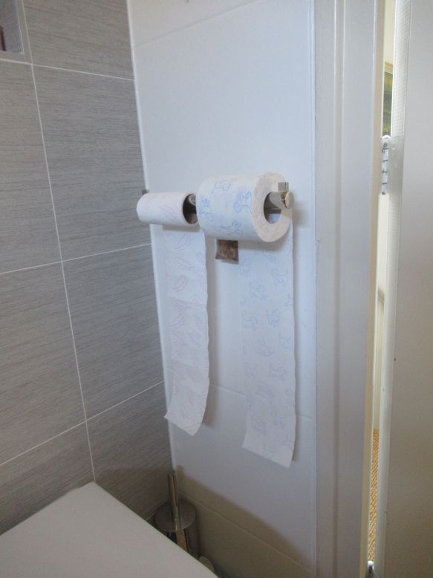Alfredo Guirit, from Tagbilaran, Bohol, Philippines.

Figure 12 Toilet rolls. With a full roll, a jerk will suffice to get your piece of paper. With an almost empty roll a jerk will unwind the whole remaining part.

## Rotational inertia 2

See figure 12. With a full roll just prepare the length you need then a jerk will suffice to get your piece of paper. If you do that with an almost empty roll, then the remaining part will unwind and give you much more than you need. The full roll has a higher resistance to acceleration, thus a greater rotational inertia. For a demo in the classroom, just borrow the rolls from the school and put them back later.

## Rotational inertia 3

Now make the set-up of figure 14, preferably with a breakable object on one side of the string such as a porcelain cup instead of the keys, but any object will do. At the other end of the string an object such as a bolt or a screw or a key, whatever. There is a pen or pencil in the left hand as a kind of pulley. Then let students predict, *If I let go of the string, what will happen?* The teacher shows some uncertainty or even fear, would this go alright? Let go! The weight will be greatly accelerated and wind itself very quickly around the pencil. That will increase the friction so much that the cup (or keys) will stop falling. For an explanation try to link with the results of demonstration 13. A nice discussion of this experiment is on the following site and this includes references to the American Journal of Physics (Marlow, 1991) for a complete mathematical treatment: <https://sciencedemonstrations.fas.harvard.edu/presentations/coffee-mug-string>

|  |  |
| --- | --- |
|  |  |
| Figure 13 Keys, string, and small counterweight. | Figure 14 With a beaker. |

## Circular motion 1

Now that we have the nice set-up of figure 15, we better also use it to demonstrate properties of circular motion. While the stopper is moving, you will cut the string with scissors just above the weight. Draw a circle on the board and let students predict whether the stopper will fly off radially or tangentially (draw the two possibilities). Let students write a prediction with a reason. Then cut the string when the stopper is moving away from the students.

Figure 15 Set-up for circular motion

## Circular motion 2

Just like in the earlier rotational inertia experiment, show what happens to the velocity when reducing or increasing the radius by pulling or releasing the string in the set-up of figure 15. Show also what happens to the velocity when you add weights while trying to keep the radius constant.

## Circular motion 3

It is possible to make this into a quantitative demonstration supporting the formula *F = mv2/r* by computing the velocity from measurement of the period *T* with a stopwatch or video from a mobile phone. Make sure to independently vary *F* and *r* while controlling for respectively *r* and *F*.

## Projectile motion 1

Throw anything away from you, its path looks like a parabola. Now display it all at the same time, ask a plastic water bottle from one of the students, make a hole near the bottom on the side and squeeze it, nice parabola. Better visible if you use ice tea or other colored drinks instead of plain water. Compensate the student for the loss of the bottle.

## Projectile motion 2

My wife Daday, also a physics teacher, made a clever device (figure 16) to show that the vertical motion and the parabolic motion of a projectile experience the same vertical acceleration, a free-falling coin and a simultaneously horizontally launched coin from the same height, will reach the floor at the same time. Just listen. To construct the launcher, just fold a piece of thin metal from a can over the end of a ruler.

## Projectile motion, relative motion

Walk with constant velocity while throwing a piece of chalk or a coin or a tennis ball straight up. It lands in your hand, *not* behind you. So it had the same horizontal velocity as you when launched!

|  |  |
| --- | --- |
|  |  |
| Figure 16 The launcher, coins are put on either side. Instead of the bamboo, use a ruler. | Figure 17 Launching the coins. Photo’s: our article in The Physics Teacher, 1990, p478. The path should have been drawn to look more parabolic. |

## Air pressure

Did any student bring a newspaper to class? Or take one from the faculty room. Is there a ruler or thin piece of wood that could be broken? Have the piece of wood sticking partly over the table edge, put a few newspaper pages over it like a blanket and push out the air underneath. Then hit the part of the wood sticking out quite hard (let a karate student do this). The paper will not tear but the wood will break.Consider the piece of wood like a see-saw pivoting at the edge of the table. The force of air pressure on the newspaper competes with the force of the hand hitting the wood.

|  |  |  |
| --- | --- | --- |
|  |  |  |
| Figure 18 Static and kinetic friction (drawing Renante Embalzado). | Figure 19 Static and kinetic friction (Photo Ineke Frederik) | Figure 20 Folding paper makes it stronger. *Corrugated* paper can carry weight! |

## Static and kinetic friction and center of mass

Take a ruler, meter stick, or any other long object available. Balance it horizontally on top of your left and right index fingers (figure 18). Then start moving the fingers towards each other. Without any control by the instructor, the fingers will only slide against the ruler one at a time and the two fingers will meet under the center of mass. You can make it more spectacular by blindfolding the instructor, same result. The experiment could easily be repeated by the students in their seats, they can try their rulers or other objects from their bags. Explanation: when one finger moves, an increasing part of the weight will be supported by that finger as it gets closer to the center of mass, so friction increases, and the other finger will start moving until it stops and the process repeats itself. Also see the 34 experiments with rulers in the *American Journal of Physics* (Ehrlig, 1994). An interesting variation is to add an object on one side of the stick, for example a blackboard eraser or hang a bag, then using the above procedure you will find that the center of mass has shifted.

## Static and kinetic friction

Take a meterstick, or pvc tube, or any other rod such as the end of a broom. Keep it horizontal and hang over it a piece of cloth (towel, hand kerchief, scarf) such that one end is much longer than the other end but it does not move because of static friction (figure 19). Then slowly tip the rod downward a bit until the cloth starts moving. It will then not just move downward, but also sideways. Friction has now become kinetic and kinetic friction is smaller than static friction thus insufficient to prevent sliding sideways (source: Ineke Frederik, Dutch physics teacher educator).

## Friction 1 (Leisink, 2006)

Take one half A4 and put it between the pages of a closed book, pull it. It is easy to pull it out. Now take 10 of these half A4 pieces of paper and put them each between different pages (figure 21). Try to pull out all 10 at once. That is difficult.

## Friction 2

When students really need a time-out, let them then interleave the pages of two books. The books cannot be pulled apart. Well-known is of course the ideal version of this experiment where two traditional telephone directories are interleaved and handles are attached to the books. Two strong people cannot pull them apart, but that is not a pocket demo anymore, but it would fit in 2 minutes if the teacher shows a YouTube version.

Figure 21 Pulling out 10 pieces of paper at once.

## Friction and heat

Students rub their hands and feel the heat. Work converted into heat, or in a perhaps better formulation: work increases the thermal energy (or internal energy) of the skin.

## Friction and normal force 1

Put a book on the table, try to push it across the table. Have a student try. Then make a pile of books (borrowed from students) and try to push. It is much more difficult; the pushing force has to be greater. So friction has something to do with the total mass of the books, or, if the normal force has been discussed, friction is proportional to the normal force exerted by the table on the books. One can have students participate and feel it themselves by having them make their own pile of notebooks or textbooks on their tables or on the writing boards of their seats.

## Friction and normal force 2

Take three textbooks and pile them flat on your hand and hold them up (figure 23). Then with a finger of the other hand you are going to push the top book. Ask for a prediction, if you push the top book, will only the top book slide, or will two or three books slide? Why? Then show, only the top book will slide. Friction between the 2nd and 3rd book is 2x friction between 1st (top) and 2nd as friction is proportional to the normal force.

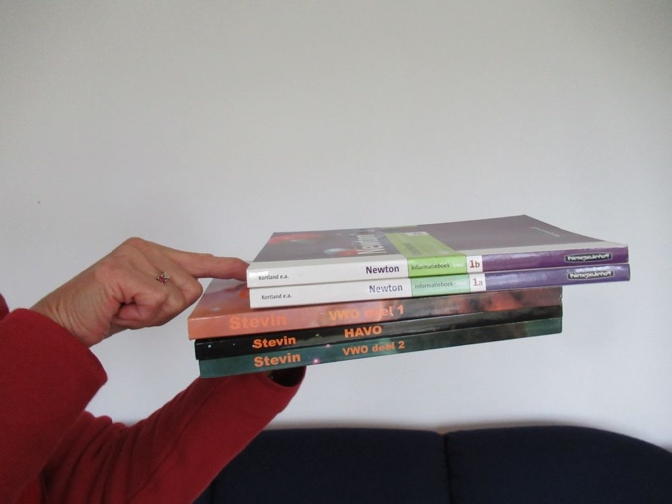

Figure 23 Friction and textbooks

## Friction and inclined plane

Tilt the instructor’s table using an object under one of the legs or using a student to hold one side of the table up. Put anything round on the table (borrow some candy from students, instructor can eat it after use). The round object will accelerate down the table surface. Put a book on the table. What keeps it there? Friction. Increase the tilt, the book does not move yet. Is the magnitude of the friction still the same? Tilt more yet, the book starts moving. Why? Make sure to distinguish between *actual* friction (*mg sinα*) and *maximum* friction (*μN = μsmg cosα)*. The instructor can even illustrate how friction coefficients are determined by taking the static friction coefficient equal to: *μstatic = tanαs* where *αs* is the tilt angle when the book is just about to slide. Dynamic friction occurs at an angle where the books once moving, keep sliding at constant speed *μdynamic = tanαd*

## Difference between static and kinetic friction

Pull a student bag across the table with a piece of elastic band or a weak spring. Movement will be kind of jerky: stick-slip movement. The elastic band or spring will be longer when the bag is not moving and shorter when it moves, showing that static friction is greater than kinetic friction.

## Strength of profiles

Put a banknote on two markers (figure 20). How can you fold the banknote such that it can carry a load of many coins? Two folds already helps a lot. If you pile more banknotes on top of each other, then they can carry many coins! Then try more folds, corrugated banknotes are very strong. Think also about all the roofing materials that have corrugated shapes rather than being flat, for example rooftiles and metal roof sheeting. A nice series of demos and comparison with carton and other materials can be seen at YouTube: <https://www.youtube.com/watch?v=qFZGmHbjLSM>

## Center of mass 1

Show with a stick or a ruler or a meter stick or even a broom stick what is the center of mass. Put the stick on the table, pull it slowly outwards over the edge. At a certain point it will start to tip over. If you support the stick at that point with your finger, the two sides will balance. That is the center of mass, it is as if all the mass is concentrated there. Human bodies also have a center of mass. *Stand up all of you. Lean forward. What do you feel? Cramp in your toes? Lean more forward yet, eventually you will have to take a step forward in order not to fall. The center of mass of our body is somewhere in the belly. If that center of mass goes over the toes, then we have to take this step forward to prevent tipping over. Could you lean forward more if you were standing on skies? Stand up again, lift your leg up (forward), your shoulders will go backward to balance, so that the center of mass is still above your feet. Lift your right leg sideways, now your shoulders will move in opposite direction. Sink through your knees, your brain already knows how to compensate, some parts of the body go forward, some parts go backward*. Every time your brain knows automatically how to compensate, that is built-in physics! A longer series of demo’s on center of mass along with some spectacular powerpoint pictures is available from the author.

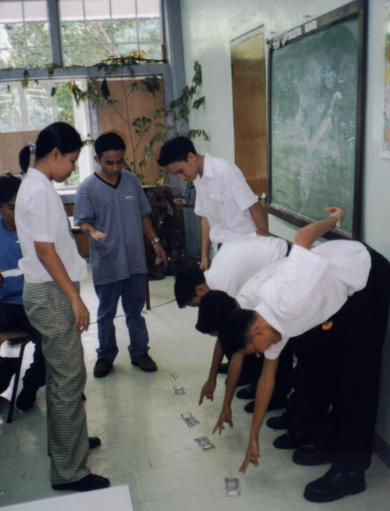

Figure 24 My teacher education students in the Philippines lining up high school students for this experiment. Notice that the students are not properly lined up with heels against the wall. The teacher could loose money!

Figure 25 University of Twente student David demonstrated this arrangement. The center of mass should be located somewhere under the table rather than next to it.

## Center of mass 2

Line up some students with their back and particularly their heels against the wall of the classroom (figure 24). Then put some money in front of their toes. If they can pick it up without falling, they may keep it. This is impossible to do without their center of mass going beyond their toes and falling.

## Center of mass 3

Take two students of unequal size next to each other facing the other students in front of the classroom. They hold each other. Then let them lift their outer legs. Total instability! Same problem, their common center of mass should be above their standing legs in the middle, but lifting their outer legs will disturb the equilibrium.

## Center of mass 4

Borrow a hammer and a stick and some rope or rubber bands and make the set-up of figure 25. Teacher education student David constructed and explained it perfectly.

## Rotation, center of mass, stability

Tilt a chair, tilt it more, there is a point where the chair will tip over. Take a simpler object, a book or a piece of wood. Try to link the position of the center of mass to the point where the book or block of wood will tip over. Take any other object in the room. When picking up a chair, boys tip over more easily than girls as their center of mass tends to be higher in the body. Instructions can be found in Liem(1987, p326).

## Pressure and surface area

Take a pencil or ballpoint, press the tip (small surface area) on the inside of your hand, now press the opposite end on your hand (large surface area). The force could be the same, but the pressure is definitely different.

## Simple machines

Usually there is a meter stick or something similar in the room. Use it as a crowbar and stick the end under a table leg or under a pile of books and pull the other end up. At a much reduced force, but increased distance, the weight can be lifted. Students can feel it themselves using their own rulers or even ballpoints and their usually heavy physics book which they *should* take to all class sessions anyway. Let them feel the difference by pulling on the middle part of the ballpoint and pulling at the end (much lighter). ADD FOTO figure 26

## Torque

Illustrate torque opening the door, turning a doorknob, or tilting the chair. With torque we make things turn around an axis.

## Torque and distance from axis

Again, use the door. Push with your finger at the end, the door moves easily but the finger has to move a great distance to turn the door through 90o. Now push close to the hinges. The force needed to move the door is much greater, but the finger only has to move a short distance to move the door 90o.

## Moment of force 1

Take a student’s bag with books, hold it at arm’s length and then hold it next to your body. Which one is easier? The moment of force, the product of force times arm, is greatest at arm’s length and we can feel that very well. Let the students do this themselves with their bags.

## Moment of force 2

All students sit on their chair. Lift one knee a bit up from the chair. No problem. Now stretch the leg and again try to lift the knee from the chair. It is a lot more difficult this time. The moment of force (force times distance from hip to center of mass of the leg) is much greater now.

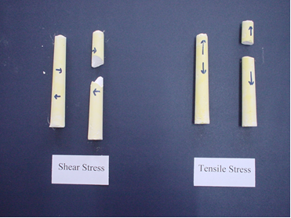Figure 27: Shear stress and tensile stress.

## Springs parallel and in series

Collect some rubber bands from your students and arrange them parallel and in series and let students feel. This is like springs parallel and this is like springs in series. This can also be done with the springs from several ballpoints. In which situation, parallel or series, can one add up the spring constants? Just use logic first using Hooke’s Law F=c.u with c as the spring constant.

## Tensile and shear stress

Take a piece of chalk. Pull on the two sides, that creates tensile stress. The chalk breaks with a very nice flat break surface perpendicular to thelength of the chalk (figure 27). Now take another piece of chalk and twist the ends in opposite directions. We now have shear stress. The chalk breaks with a very different break surface. Try it, the effect is crystal clear and can be found Feynman’s Lectures of Physics II p39-9.

## Collisions and preventing damage

Anybody has a raw (uncooked) egg? Now this is something you might not have in a bare classroom, but then bring it from home. Have students hold up a towel, a coat, or any piece of textile, or the curtains of the classroom window. Then throw the egg full force into that (figure 28). It will survive, it will not break. There are two principles at work. The force that decelerates the egg is spread over the surface of the egg, rather than applied at one point. Furthermore, the decelerating force is spread in time as the towel or curtain moves along with the egg. The spreading of forces also applies to seatbelts in cars and protective helmets, they spread the force over the body or over the head. Seatbelts also illustrate both the spreading in time and in area of the decelerating force as the belt is wide moves along with the body, thus lowering the force by spreading it in time and across a wide surface.

## Breaking or not?

Look around for something that can break if dropped on a stone floor. Then look for things that can prevent that using the two principles. For example, pillows, not part of a bare classroom, but perhaps available in the school. Or make a pile of some student coats or other clothing. There may be some foam somewhere. Then drop a glass or an egg. How are breakable objects usually packages in stores? Students will give examples and even may have some in their bags. How do girls make sure their cosmetic flasks do not break in their bags?

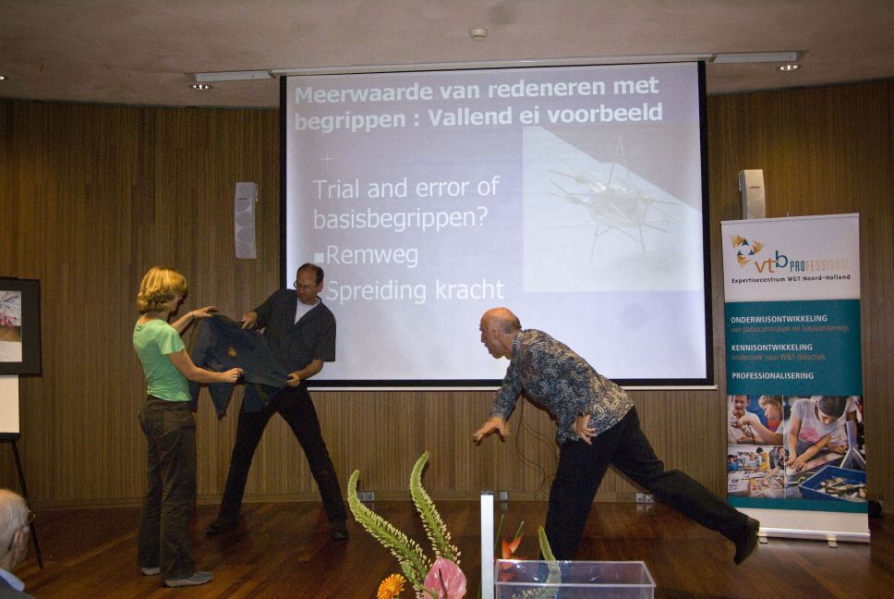

Figure 28 Author throws a raw egg with high speed into a coat. Gerda Manneveld and Frank Schweickert assist.

## Bernoulli 1

Hold a sheet of paper as shown in figures 29 and 30. The top end will be hanging down a bit. Blow across the paper. The top end will then move upward. A simple way of explaining is that you blow some of the air above the paper away, creating a pressure difference with lower pressure above the paper while having the normal atmospheric pressure below. A more correct explanation is that moving air has a lower pressure than air standing still. This pressure difference pushes the paper up. Instruments based on this principle are used to measure an airplane’s speed relative to the surrounding air.

|  |  |
| --- | --- |
|  |  |
| Figure 29 Daday blows across the paper that is pushed up by a pressure difference. | Figure 30 from T. Liem, Invitations to Science Inquiry4 |

## Bernoulli 2

(Before or after the previous demo) Continue the demonstration, tear another page from a student’s notebook, hold the two pages on the bottom end while the top ends of the paper are pointing parallel towards the students. Then ask students what will happen when you blow in between the pieces of paper and why. Then blow, the papers are moving towards each other rather than away from each other.....Bernoulli! Now of course you should have brought one of those toy helicopters to class as the climax to your Bernoulli demos. However, do not forget that it is not only the Bernoulli principle which makes airplanes fly, the reaction force on the wings due to downward deflection of air currents is a major force (Weltner 1990a, 1990b).

## Bernouilli 3

Light a candle. *If I blow through a straw on the window side of the candle, will the flame move? Which way? Why?* Answer: the flame will bend to the window side, the burning gases of the flame will point towards the area with lowest density/lowest pressure (figure 31). In faster moving fluids the pressure is lower than in slower moving fluids (Bernouilli). For a younger audience: I blow some air away, the burning gas moves to the place with least air. For figures, see the chapter on Heat and Temperature.

Figure 31 The flame bends to the side where we blow the air away, towards the lower pressure of moving air.

## Energy conversions

Drop anything and you get conversion from potential into kinetic energy, rub your hands (mechanical into thermal energy), clap your hands (mechanical into sound), point to the lights in the room (electrical energy into light and heat), etc.

## Work and kinetic energy

There are rulers with a gutter (figures 32 and 33). Let a marble roll down and investigate the relationship between initial height of the marble and the displacement of the cup or wedge of carton. Using graph paper helps to get better measurements.

|  |  |
| --- | --- |
|  |  |
| *Figure 32 Version of Freek Pols (2023).* | *Figure 33 Version of Patricia Kruit (2018).* |

## Asymmetry in properties, friction of hair

Ask a hair from a long-haired girl or propose that each student pair takes a hair from one of the two heads. Hold one end between thump and index finger of one hand, and slide with the other thump and index finger along the hair. Then slide in the other direction. It turns out that the friction of the hair is dependent on the direction of the sliding of thump/indexfinger.!

# LIQUIDS AND AIR

An article with 30 demonstrations with a glass of water is available from the author and in GIREP proceedings (Berg, 2020). These demo’s cover mechanics, liquids, optics, waves, and even electricity.

## Liquids: Anybody with nail polish, coca cola, or something else that is liquid?

Whatever is there, use it to see that the liquid surface is always horizontal; look at the edges of the meniscus: adhesion, cohesion; look at waves on the surface when disturbed with a pencil, study how easily the fluid goes down when the bottle is turned over, or is it slow and sticky?

## Floating and sinking

Take all kinds of materials and objects and see whether they float or sink in a glass of water. Students would have lots of objects in their pockets. Some materials like clay or aluminum foil would sink, but if folded might float. From aluminum foil one could fold boats that can carry a load and still float. A Kindergarten class tried to fold pieces of foil of fixed area such that they would hold the maximum number of tiny St. Nicholas presents (tiny blocks or Lego pieces).

## Floating and sinking

Anybody brought a tangerine? Will it sink or float in water? Why? Try it out. Then peel it and try again (figures 1 and 2). Try other kinds of fruits and explain the results.

|  |  |
| --- | --- |
|  |  |
| Figure 1 Floating tangerine | Figure 2 Sinking pieces of tangerine |

## Adhesion in a glass of water

See how the meniscus of water in a glass stands up to the wall, adhesion, that is attraction between two different substances, in this case glass and water.

## Adhesion on a penny

Rinse a penny or other coin in tap water and dry completely and put it then on a paper towel or paper handkerchief. How many drops will fit on the penny? Record some predictions on the board. Then add drops one by one with a dropper until any amount of water runs over the edge of the penny. If you have more droppers, students can do this in their seats (Hammack & DeCoste, 2016).

## Adhesion and crumbs

Another example is picking up crumbs of cookies or bread from a plate, we lick our finger first and then the crumbs stick to it. That is an example of adhesion between water and crumbs. In class demonstrate this with a wet finger and very small pieces of paper like those coming from a perforator or -tastier- try cookie crumbs.

## Capillarity 1

If you do have a very thin glass tube, then stick it into a glass of water and see the water move up ... capillarity. Otherwise, take a piece of paper and dip in one end, the water will move upward in the paper. Try different kinds of paper. With the hair of a paintbrush or human hair, the same phenomenon occurs, “capilla” is the Latin word for hair. Capillarity can be seen as a tug-of-war between adhesion and gravity (Rogers, 1960, p95). Water creeps up the glass wall due to adhesion and is pulled down by gravity. In very thin tubes the gravitational pull on the water creeping up the wall is smaller compared to adhesion than in wider tubes. Adhesion scales with surface area and gravity with volume. Capillary tubes have a large surface area compared to their volume.

## Capillarity 2

Bring a sugar cube and a cup of coffee from the teacher room. Dip the edge of the cube in the coffee. Coffee will quickly *climb* into the cube, capillarity!

## Cohesion

Fill a glass all the way to the top with water but such that the surface of the water is still concave. Then collect coins from your students. How many coins can I add without letting the water overflow? Then carefully insert the coins. Lots of them can be inserted in the water. In the end the water will bulge higher than the rim of the glass but it will still not flow down along the sides of the glass: cohesion!FOTO

## Adhesion and cohesion

Use a straw or other means to make a drop of water on the table. Use different materials as surface (glass, wood, metal, plastic, paper). Rub some fat or wax on the table. Does that make a difference in the shape of the drop? Add some soap or detergent to the water. Does it make a difference in the shape of the drop? On which kind of surface is cohesion at a maximum? At what kind of surface is cohesion at a minimum?

Why is a drop of water round and the surface of a lake flat? This is the contest between surface forces and gravity. Think of a cube with side *a*, surface area 6*a2*, and volume *a3*. Let *a* increase, then the surface area thus also surface forces scale as *a2*. The volume thus also volume forces like weight scale as *a3*! With large amounts of water the volume forces dominate and so the surface of a lake is flat. With small amounts (a drop and smaller) the surface forces dominate such as with surface tension and capillary phenomena. A beautiful discussion can be found in Rogers (1960, p92).

|  |  |
| --- | --- |
|  |  |
| Figure 3 Meniscus above the rim (convex), pieces of cork in center. | Figure 4 Meniscus below the rim (concave, hollow), pieces of cork on the side. |

## Floating on convex and concave surfaces

Fill a glass of water until just below the edge (concave surface) and then fill another glass carefully until the water level is over the edge of the glass but the water does not drip down the outside of the glass. Draw the two situations on the blackboard or whiteboard. We are going to put a ping-pong bal (or anything that floats) on top of the water surface. Which way will it position itself, in the center or against the edge of the glass? Let students draw their prediction in their notebooks. Walk around to take a look and ask a few students for a reason. Then drop some floating material on the surface such as a ping-pong ball or pieces of cork or anything that floats. And then let students explain, perhaps first in small groups of two or three. In the end draw some explanations on the board and discuss. The pin-pong balls or other floating objects will go to the highest position and displace water downward. Objects that sink will displace water upward. See cork on convex and concave water surfaces in figures 3 and 4.

## Chromatography

Take a strip of paper, make a big dot with a black marker. Then hang the edge of the paper in water (see figures 5 & 6). The water will move up (capillary motion), pass the black dot, and beyond that one will see a separation of colors. The different pigments in black ink move at different speeds in the water. That is how pigments can be separated. The same principle is used with chromatography which can be executed with different liquids and even different gases. Google on chromatography in the classroom and you will see many experimental possibilities. <https://edu.rsc.org/primary-science/kitchen-roll-chromatography/4012057.article>

## Air pressure and liquids

Take a straw and a glass of water. Dip the straw in the water, close the top with a wet finger, then lift the straw out of the water while keeping the top closed. Why does water remain in the straw? This is a way to transfer small amounts of water. In a traditional pipette, one can suck up a liquid and measure exact amounts using the markings.

## Air bubbles

Now close the top of the straw with your finger before inserting it. Now the water level in the straw will be below the water level in the glass. The latter will be clearer when we have a basin with water and push a glass upside down into it. There is something which prevents the water from coming in, air. The air in the glass can be compressed, but not all the way. Students can be reminded of their experiences when washing dishes. Try to pass air bubbles from one glass to another in the basin. Bubbles will move to the highest point available. Or stick a straw up to the bottom and blow air through it. The bubbles will mover straight up in the water.

## Transferring air bubbles under water

Take two glasses under water in a basin. One is filled with water, the other is pushed upside down into the water thus is filled with air (see previous demo). Try to transfer the air to the other glass. How would you do that? Play around a bit with the air bubbles, it is fun.

## Air occupies space

Take a basin with water, a glass with a piece of paper handkerchief at the bottom, turn the glass upside down and push it into the basin (figure 7). Does the handkerchief get wet? What prevents it from getting wet?

## Carbonated drinks

There always is a student with a carbonated drink in the bag. At the factory the CO2 is mixed with the drink. As CO2 has a lower density than water or whatever drink, it will tend to escape from the liquid and from the bottle. When opened, the pressure releases. When put in a glass we see bubbles rising. Why don’t bubbles rise when the bottle is still closed? There seems to be an equilibrium between the CO2 above the liquid and the dissolved CO2. Once opened the pressure in the top of the bottle is reduced and more of the dissolved CO2 rises to the surface.

## Pressure, bubbles, straws

At the 1998 GIREP meeting Leon Jablko (1998) presented a series of pressure experiments with straws and glasses of water. The series could be teacher demo’s, or synchronized teacher and student demo’s, or it could be a student lab investigation (figure 8).

## Atmospheric and liquid pressure, cohesion and surface tension

air

water

Figure 12

Figure 9 Glass with water and air upside down and closed by a handkerchief.

Shouldn’t there always be a glass of water in the room? If so, then first have somebody help you to spread your clean handkerchief horizontal and pour water from the glass through the handkerchief to water the plants. Then put the handkerchief over the top of the glass with the remaining water (have a refill up to ¾). Make sure the wet part of the handkerchief covers the open end of the glass. Then turn over (figures 9 and 10). Surprise, a little water comes out, the rest stays. While the glass is upside down, walk around the room to show. Point to the shape of the part of the handkerchief that “supports” the water.

Explain by applying Boyle’s Law to the trapped air and by the need for the sum of pressures/forces on the handkerchief to be zero. Pair outside = Pair trapped + ρgh where ρ is the density of water and h is the height of the water column. The cohesion and surface tension of water helps to make the handkerchief impenetrable. I have done it with a strainer also, more spectacular but it requires more preparation as not all strainers work. Of course, if students bring any drinks to class, one could try which liquids work and which do not and the instructor can have a good time. *Anybody with beer?*

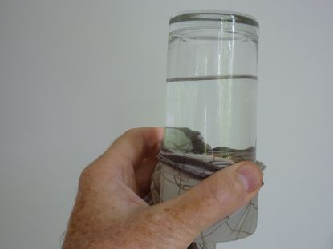

Figure 10 Glass of water closed by wet handkerchief and turned over.

## EB04Fig2ZonderDopProjectile motion with water

Figure 11 Falling bottle with tea with hole near the bottom.

Many students bring water bottles to class. With a pin or your knife make a

little hole in the side of the bottle, just above the bottom. Water will come out and make a beautiful parabola.

## Liquid pressure

Same bottle, screw the top tight. Water will still come out of the hole, but for how long? Does it stop? What happened to the pressure inside the bottle while the water was still going out? Consider a drop of water near the hole, draw the forces on the drop.

## Liquid pressure and free fall

Bottle without top but with the hole. Water will come out, now drop the bottle. Did water come out while the bottle was falling (figure 11)? Why not? Repeat with the lid on (same result). What will happen in the space station if you turn a bottle upside down with the lid off?

## Emptying bottles

This experiment requires a basin unless you hold the bottle outside an open classroom window. Turn de bottle with water upside down. The water will come out in bursts. It is difficult for air to come in and replace the water. Then swirl it. Now the water will flow out continuously as air can flow in through the center to replace the water. You can also just tilt the bottle such that air can flow in while water is flowing out. If you have a basin, you can hold a competition between the vertical bottle without swirl, one with swirl, and the tilted bottle. Which one is empty first?

## Emptying beakers/glasses

Put 2 or 3 pairs of students in front of the class, each with a table with a small bottle of water half full, a straw, and an empty glass. The task is to empty the bottle without lifting it. Some students will cleverly think that the straw could be used as a siphon. By blowing through the top of the bottle (with the straw siphon) one could even reinforce the working of the siphon (by blowing increasing the pressure above the water surface), however, just sucking up the water into the mouth and then spitting it into the glass works faster. Use this opportunity to ask students again to explain the physics of a straw and of a siphon.

## Liquid resistance

In air stones fall with the same acceleration g. But how is that in water? Take stones with a different surface area to mass ratio and drop them in a basin with water. Which one will sink faster?

## Liquid versus vapor balance, relative humidity, saturation, open versus closed container:

Take two containers of water, one with an airtight lid and one without, put them on the windowsill in the sun. Figure 11 and 12 show the differences. In figure X we see condense on the inside of the glass above the water. The air above the water is saturated, 100% humidity, so water that evaporates will condense again. In figure Y we do not see this, any water that evaporates goes into the air, so the air right above the water is unlikely to reach 100% humidity unless the room is extremely humid.

|  |  |
| --- | --- |
|  |  |
| Figure 12 Closed and open container from above. | Figure 13 Closed and open container from the side. |

## Bernouilli and a candle flame

Light a candle, why does the flame point upwards? The heated air above the flame expands and becomes less dense (figure 14). The burning gases along the wick move towards the location with the lowest density (lowest pressure). When I blow softly at the flame without extinguishing it, which way does the flame go? In the direction of the blow. And when I blow through a straw on one side of the candle? Then the flame bends towards that side, as there is the lowest pressure (figure 15), a nice illustration of the Bernouilli effect. Explanation for a younger audience: I blow some air away, the burning gas is pushed to the place with least air.

|  |  |
| --- | --- |
|  |  |
| Figure 14 The candle flame is straight up as heated air above the candle expands and density decreases. Burning gas and hot products flow towards the lowest density. | Figure 15 Blow through straw to the right of the flame and the flame bends to the right. Keeping the straw vertical next to the flame also works. |

## Lift water by blowing

Use two transparent straws or cut and bend a straw as in figure 16. Take a glass of water. Position part of the straw in de glass, bend the rest (with a partial cut) horizontal. Then blow in the direction of a vertically held piece of paper. It gets wet. Use some ink or food coloring to make it more visible. Explanation? Fast moving air has a lower pressure, thus the water is sucked up through the vertical part of the straw and sprayed onto the paper. Practice a little bit before the lesson.

# ELECTRICITY

## Static electricity and textile, ballpoint pen and paper

Let students tear tiny pieces of paper from their note books, rub their ballpoints on their sweaters, and approach the pieces of paper with the ballpoint pen. Both electrostatic attraction and repulsion (after touching the ballpoint, the pieces of paper will be repulsed).

## Static electricity and balloons

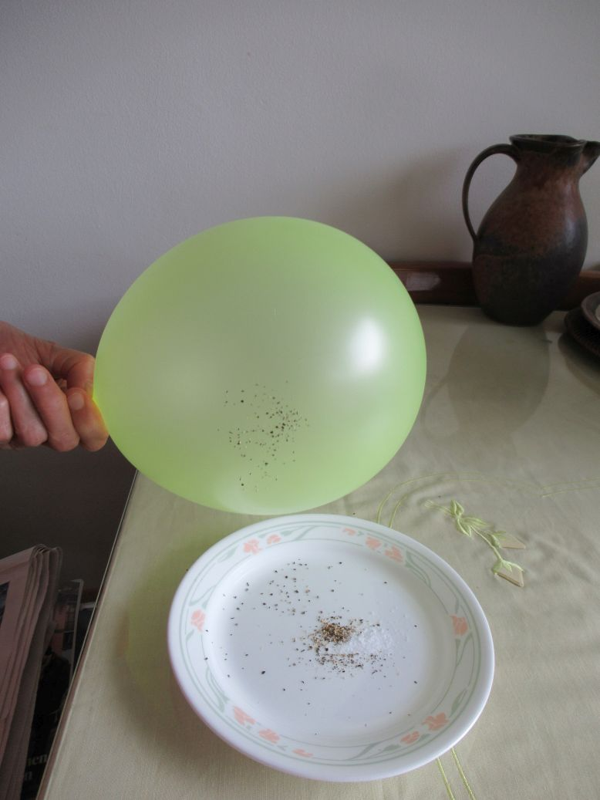I always have a balloon in my bag. There are many uses in teaching physics. Just rub it on your clothing, stick it to the wall, or see how pieces of paper react, or the long hair of your students or the hair on their skin.

Figure 1 The rubbed balloon attracts pepper but not salt.

## Salt and pepper

In school cafeterias or in the faculty room one can find salt and pepper for the soup. Mix some salt and pepper. Then rub a balloon with a piece of cloth, your sweater or other materials students wear, might work, and hold it above the mixture. The pepper will be attracted, the salt will not be (figure 1). Instead of the balloon, one could also use a plastic ruler. The pepper will be attracted by induced separation of charges. Now why didn’t the salt get attracted? Are the grains too heavy or is salt is too conductive?

## Straws

I always have some straws in my bag, but usually they can be obtained from the faculty room of the school. Rub with a paper hand kerchief, then there is a possibility the straw will stick to the wall, or to a metal object such as the leg of a chair. If it does not work so well (humidity in a room full of students), then usually the straw will still attract the hair on the skin. But that can be done also with a ballpoint after rubbing with your sweater.

## Coulomb’s Law

Ask how much charge there could be on a ballpoint or a straw. Because of the large constant in Coulomb’s Law (9x109), charges must be quite small, certainly smaller than 10-8 C. If q1 = q2 = 10-8 C, then FCoulomb= 9 • 109 • 10-8 • 10-8/10-4 N, assume a distance of 1 cm, and the result is 1/100 Newton.

## Water molecules are dipoles

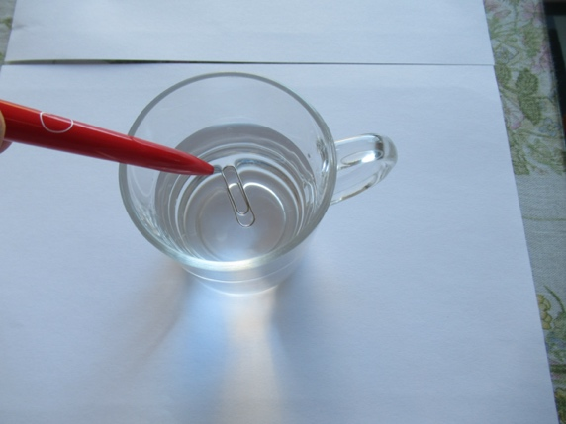Use a fork to position an aluminum coin or paperclip very carefully on top of the water surface in a glass of water. Then rub a plastic pen or straw on your jumper or other textile and let de tip of the pen or straw approach the end of the paperclip or the coin (figure 2). The paperclip will move away from the tip of the straw. How come? Start a discussion. Let students propose explanations. If it was electrostatic induction between coin and straw, then there should be attraction rather than repulsion. In the end somebody might suggest that the water has a role. Water molecules are dipoles. The straw attracts the water creating a little slope and the coin or paperclip slides down that slope. Actually, the slope could be shown by reflecting an almost horizontal beam of a laser pointer from the surface of the water. When the charged straw come close to the surface, the reflected beam moves. Could an electrostatic generator be used an outboard engine?

Figure 2 Rubbed plastic and floating paperclip.

## Flow of electricity compared to water

Switch on the light, the effect is immediate. Switch on the faucet....it takes some time. From this you may want to get into field driven (electricity) versus particle driven (water) motion. The water is like the traffic when a red light turns green. Electricity is not. Fluorescent lamps may spoil your demo as they can be slow to light but they are on the way out anyway.

## Conductors and insulators

Bare classroom? Just bring a battery, a small bulb in a holder, and some wires. They do fit in your pocket. Then in interaction with the class try out materials to see whether they conduct electricity or not. Kids may be surprised with the core of a pencil.

## Circuits

Nowadays even bare classrooms, often have a beamer and internet connection, so with PhET simulations you can show any circuit. If there is no beamer, students will have telephones and can log into PhET. So you can even do a simulation lab activity.

## Role-play to distinguish between electric current, power, and voltage

Students (= electrons) with bags of energy (energy per unit charge = voltage) move through light bulbs and deposit their energy (conversion from electric energy to light/heat) and return to the battery to get another load of energy. The electrons are conserved in the process as they are only carriers, the “trucks” that transport energy through circuits. It is the energy that gets transformed. The power increases when the current increases (more trucks that deliver energy) and when voltage increases (more load per truck and more current). One can play series and parallel circuits, etc. Complete roleplay instructions are available from the author, but also consider Sefton’s (2002) very valid criticism of carrier analogies for electricity and Muller’s Veritasium video. (2021). As any model, visualization, or analogy to facilitate learning, the roleplay is a scaffold for learning but in the last step of the process the scaffold should be taken away and the teacher will point out both the benefits and the flaws of the model. FIGURE

# MAGNETISM, ELECTRO-MAGNETIC INDUCTION

## Properties of magnets

Make an inventory of where we encounter magnets. Does anybody have something with a magnet, to close a bag, or a telephone cover, whatever? It is unlikely that there is no magnet in a bare classroom with students. Then find out where are the poles, what are the shapes of the magnets, which materials are attracted and which are not, etc.

## Magnetizing a needle

Once there is a magnet in the classroom, there would also be a needle that can be magnetized. Just rub with the magnet along the tip of the needle and then try whether the needle can now also attract or be attracted to iron objects.

## Magnet in mobile phone holder

The function is to sense when the phone is used and when it is closed in order to switch the screen on and off thus preserve battery charge.There are more magnets in the phone, such as in the microphone and in the speakers to convert sound into electric signals (microphone) and the other way around (speakers).

## Compass

Does anybody have a pocket knife with a compass? Show inclination and declination. Use the compass to indicate North, is that really the true geographical North? If there is a globe in the room, you can indicate the difference between magnetic and geographical North pole. The magnetic one is somewhere between Greenland and Canada. Use strings on the globe to make the declination visible on the surface of the globe, one string from your location to the geographic North pole, and one from your location to the magnetic pole. The difference in direction is the angle between the strings. *Can you point to a location on the globe for which the declination is 180 degrees? And a location for which declination is 0 degrees?*

## Generator 1

Is there a student in the room who still has a bicycle with an old-fashioned dynamo and working lights? Agree with the student that next lesson (s)he takes the bicycle to the classroom. Show how the light intensity varies with the speed of the wheel. You might only see one wire but there are clearly two poles and two paths for the current, point out how that works on this particular bicycle.

## Generator 2

Of course, I do hope you have proper demonstration equipment to demonstrate a generator and an electric motor.

## Electric motor

One of my teacher education students made a functioning electric motor using one battery, some Neodymium magnets and a copper wire bent in a clever way (Figure 1). A more reliable design is shown in a simple video: <https://www.google.com/search?client=safari&rls=en&q=simplest+electromotor&ie=UTF-8&oe=UTF-8#fpstate=ive&vld=cid:0bd621c8,vid:OKpmp7R6vBU> Yet more clear instructions are in: <https://www.google.com/search?client=safari&rls=en&q=simplest+electromotor&ie=UTF-8&oe=UTF-8#fpstate=ive&vld=cid:d9ecaaf6,vid:WI0pGk0MMhg> If you cannot find these, google on “simplest electromotor”.

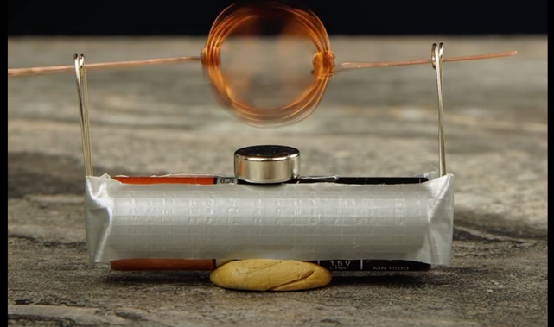

Figure 1 Electromotor

## Visualizing magnetic fields in coils

Use any kind of rope available or even the long strap of a bag and illustrate how one could wind a coil for clockwise or anti-clockwise current. Use the righthand rules to show how to find the direction of the magnetic field generated by a winding if the direction of the current is known.

## Visualizing magnetic fields around wires

Let a student in front of the class each hold a rope or bar vertically. Imagine that these are current carrying wires with the current going up in both ‘wires’. Let another student illustrate application of the right-hand rule to find the direction of the magnetic field of each of the wires. With equal and parallel wires, do the fields between the wires add up or subtract? Now imagine opposite directions, let the student again illustrate the right-hand rule. Do the fields in between add up or subtract?

## Visualizing the Lorentz force

Same situation as above, let a student use the right hand to illustrate the direction of Lorentz force on each wire, both in the parallel case (attraction!) and the anti-parallel case (repulsion). If you do have the equipment, then show!

## Lorentz force in a coil

You always have your slinky with you. Hold the top end so the slinky is suspended from your hand. Propose that the direction of the current in this ‘coil’ is from right to left in the part of the slinky facing the students. Now let pairs of students figure out the direction of the Lorentz force on two successive windings. If there were a current, would the slinky become shorter or longer? If you do have the equipment, then show!

The following demo’s use a neodymium magnet, not found in a bare classroom, but easily brought to class.

## Magnetic brake

Take a string, attach a nail or paperclip, and attach the neodymium magnet to the nail or paperclip. We can now have a hand-held pendulum which will swing like any other pendulum. Take a piece of aluminum foil or better yet a sheet of copper or aluminum of say 5 x 5 cm or 8 x 4 cm whatever. Hold the magnet against the metal sheet and show that there is no attraction. Then let the pendulum swing free at first and then over the copper or aluminum sheet. It stops! Why? The moving magnet induces Eddy currents in the metal sheet. There is energy transfer from pendulum to the metal sheet.

# HEAT AND TEMPERATURE, PHASES

## Hand as thermometer

Some classrooms have hot and cold water. If yours does not have, then send a student to quickly to get 3 beakers of water, one hot, one lukewarm, and one cold. Then let some (or all!) students put one finger in hot water and one in cold and then transfer both fingers to lukewarm. What do you feel?

## Adding temperatures or not? Intensive versus extensive variables

I have 5 glasses of water from the faucet, each at a temperature of 20 oC. When I put two glasses together, what will the temperature be? A) 20 oC, B) 40 oC, or C) just a bit less than 40 oC? Nobody will get that wrong? Well, take a blind vote (students close their eyes and raise their hands with one finger for A, two for B, and 3 for C. You can check by having a student put the finger in a single glass and in the container with the contents of two glasses together. Now another question (figure 1). We have a metal bar and cut it into a piece X and Y and the volume of X is twice the volume of Y. The relationship between the densities ρx of X and ρy of Y is:

1. ρx = 2ρy

X

1. ρx = ρy
2. ρx = ½ ρy

Figure 1 Density

Y

Here quite a few students will go wrong. One could ask similar questions about other materials properties such as specific heat, specific resistance. Which physical properties can one add? Mass, weight, volume. Which cannot be added (temperature, density, material properties)?

## Heat and friction

Rub your hands, what do you feel? Stretch a rubber band several times and hold it on your upper lip to feel the rise in temperature.

## Conduction

Let students feel different materials, for example the metal of chairs, wood, plastics, textiles. How warm does it feel? Is it possible that these materials in the same classroom have a different temperature? If the temperature is really the same, the classroom environmental temperature, how come materials feel differently, metals feel cold, textile materials feel warm? The answer is conduction!

## Convection

What are the hot spots of our body and what are the cold spots, for example when we are outside in winter? How do we explain that? Blood circulation, distance to the main arteries, convection!

## Roleplay: Melting-boiling-condensing-solidifying

Get a group of 15 students (actors) up front and make 3 rows of 5 facing the audience. First arrange them neatly into a “crystal”. Start at the absolute zero, they are moving a little bit (there *is* movement at the absolute zero, remember Heisenberg!). Then crank up the temperature (the teacher uses his/her hand to indicate temperature, the hand moves up then temperature goes up) and the actors start oscillating around their fixed spot more and more wildly. Pass the melting point and actors leave their fixed location but stay in a bunch. Pass the boiling point and the actors fly out all over the room. Call them back before they are too far and start the opposite process of condensation and solidifying into a neat crystal. Throughout the activity ask the audience what the actors should do. Pass the melting point ... what should the actors do? Keep asking questions which force students to think back-and-forth between atoms/molecules and this people model. What is the difference between boiling and evaporation in this model? Evaporation can only happen on the outside, at the surface. So only an actor on the surface can “evaporate”. With boiling, gas bubbles can form inside the liquid. The danger of this activity is a reinforcement anthropomorphic thinking: assigning human characteristics to atoms. So conclude with a discussion of differences between atoms/molecules and this people model. And then go to another model, for example, a PhET applet. Can atoms escape from the solid phase? Yes, sublimation. It can be played in the roleplay, but in reality it is only one in zillions of atoms that can escape. Some solids have a smell, that clearly is an indication of sublimation. A toilet refreshener is based on sublimation and there it is so much that in the end most of the solid is evaporated. But take iron, rightly or wrongly I think I can smell it but an iron bar will not evaporate away so it is only one atom in zillions that escapes. Our noses are very sensitive.

## Melting and plate tectonics

Afbeelding met chocolade

Door AI gegenereerde inhoud is mogelijk onjuist.*Anybody’s got some chocolate in his bag? Take the wrapper off and hold it in your hand while all of you work on this little assignment* (give them a task). After a few minutes: *show your hand to the class, what happened? Yes, the chocolate melted. This is what melting looks like. What do you think the approximate melting temperature of chocolate is?* Chocolate happens to melt somewhere between 33 and 37oC, just a bit below body temperature. So do not put chocolate in your pockets. The gradual process of melting chocolate is nice to observe. Think of the asthenosphere, the earth’s 3000 km thick layer of hot semi-fluid rock under the tectonic plates of rock. I always think of it like butter or partly molten chocolate. So it can flow and take the tectonic plates along with it, several cm per year.

Figure 2 Partly molten chocolate

## Cooling effect of narrow nozzles (Hewitt, 2015)

Exhaling with mouth wide open (warm), exhaling through small opening in lips (cold). Let your students do and feel this themselves (figures 3 and 4). Expanding air cools. Compressed air heats up (feel the bottom of your bicycle pump). Or would evaporation also play a role in cooling here? Several simple follow-up experiments are possible to further investigate this.

|  |  |
| --- | --- |
|  |  |
| Figure 3 Exhale with mouth wide open. | Figure 4 Exhale through small hole. |

## Evaporation and cooling

Let a little bottle of alcohol or acetone go around with an eye dropper. Students put a drop on the back of their hand and experience the cooling effect. Sorry, this experiment requires something to be taken in from outside the lecture room, but there is a good chance one of the girls can produce some nail polish remover. If so, borrow it, and pay something for replacement.

## Evaporation/condensation

In winter in cold countries look at the windows, why is there water on the inside of the window? The increasingly common double glass has decreased the effect. Better yet, do take a glass with cold water or a can of cold drink to class! If you forgot, take a glass of water from the faucet and breathe on it. It will get foggy on the outside as long as the water temperature of the glass is lower than your breath which should be near 37 oC when exhaling with the mouth wide open.

## Evaporation and diffusion

There must be a student with a bottle of perfume in her bag. Open it, and after a while we can smell it from a distance. Or promise the girl a new bottle and put a drop on the hand of a few students and let them go around and let all students smell.

## Sublimation

The above experiment will also work with a piece of solid soap, there should be a piece in the school somewhere. If not, see whether students have any solids in their bags that smells (food?). Sublimation! Or is it a solid material that contains some gas that we smell and is it not sublimation?

## Energy transport: conduction, convection, evaporation, radiation

Remember that “heat transport” can take place through conduction, convection, radiation, and evaporation (which is a special form of convection). Actually, heat transport is a wrong term as heat is defined as energy moving between systems, thus energy in transport. A better term might be transport of thermal energy. Anyway, a trivial experiment, bring your hot cup of coffee from the teachers’ room to class. How does the coffee cool? *What is conduction? How can I feel that?* Touch the sides of the cup. *What is convection? How can I feel that?* Hold your hand above the cup. *What about evaporation?* *How can I show that?* Put a cold object (like a saucer) right above the cup, drops will form under it from evaporated coffee which condenses on the colder object. *What is radiation? How can I feel that?* Put your hand a bit away from the cup, but perhaps better, borrow a water cooker from the teacher room.

## Keeping water warm

Take two beakers of hot water, or better, take a full thermos and two beakers and some additional material such as saucers, a towel, old newspaper. *I am going to fill the two beakers with hot water. How can I keep it warm longer? How do I prevent conduction, how convection and evaporation, how radiation?* Take student suggestions, then insulate one beaker and use the other as control. Having two thermometers would be a great help, otherwise use the finger of one of the students. While waiting for the cooling, give students some questions or problem solving to chew on. I used to do this as a lab activity for all students but then with thermometers. In a first round they would just measure cooling of two open glasses to practice taking temperature-time measurements. In a 2nd round they would insulate one glass in whichever way and compare with the uninsulated glass. In a third round they learned first about heat transfer through conduction, convection, and radiation and then redesigned the insulation. That third round resulted then in quite good Joule meters, good enough to do specific heat measurements (Berg, 1987).

## Cooling water quickly

One could also do the opposite. Bring a hot coffee from the teachers’ room. *It is still too hot to drink, what can I do to cool it fast?* Stirring? Blowing across the top of the cup or beaker? How does this relate to conduction, convection and evaporation? (Stirring stimulates cooling at the surface through convection/evaporation. Blowing across keeps removing the evaporated and saturated coffee/water vapor thus accelerates cooling through evaporation).

## Conduction, convection, radiation with a match or lighter

Now these may not be common objects in a bare classroom anymore but should be standard in the pocket of a science teacher. With the matches one can demonstrate conduction (hold a metal object in the flame), convection (hand above the flame, but not too close), and radiation (hand to the side at some distance).

The following candle experiments can be done by the teacher (with a big candle in a darkened room and preferably with a webcam), or synchronous by teacher and students on their desks, or as student lab. Obviously when students have candles on their desks, more candles and matches are needed and it is no longer a “pocket” demo.

## Describing candles and flames and formulating questions

A candle should be a standard object in the bag of a physics teacher, just like a balloon, a ruler, and matches. Let students describe what they see: a) unlighted candle, b) lighted candle, c) just extinguished candle. Let them then think of explanations and follow-up experiments to test their explanations. For example, the unlighted candle consists of wax and a wick. Can the wax itself be made to burn with a match? (No) What is the function of the wick? Can liquid wax be ignited by a match? (No) Draw a flame, put in the colors. There seem to be three regions: blue, grayish-yellow, and bright yellow. What questions can be asked? See Faraday’s 1860 beautiful and very readable description of candle experiments in Hammack (2016).

## Candle, what is it that burns?

Try lighting the solid wax, it does not burn. Look at the molten wax, as if it does not burn. Turn the candle upside down, the flame gets extinguished. The liquid wax kills the flame! What is it then that burns? Light the candle, then extinguish it, and then quickly hold a lighted match at some 5 - 10 cm from the candle in the resulting whitish smoke. Wow, a flame again. It was the wax *vapor* that can easily be ignited. When the wick is lighted, it burns, it melts the wax, it heats the wax until vapor creeps up the wick through *capillarity* and the vapor is what burns. There is a small distance between liquid wax and the bottom of the flame. So the vapor burns at a few millimeters above the liquid wax. (Faraday in Hammack et al, 2016).

## Exploring the temperature pattern of the flame 1

The tips of unlighted matches can be used as temperature sensors. When approaching the flame slowly, at a certain distance it will ignite, that is where the temperature equals the ignition temperature of the material at the tip of the match. Now try this around the flame and that will produce an “isotherm” of the ignition temperature around the flame. Near the bottom of the flame one can come quite close with the match. Above the flame the match ignites at much greater distance from the flame. Explain! Liem, 1987, p205).

## Exploring the temperature pattern of the flame 2

Exploration can also be done with a piece of paper by the teacher only. Hold a piece of paper horizontally above the flame and look at scorching pattern. Obviously strips of paper can also be used instead of the matches of the previous demo. The typical ignition temperature of paper is usually somewhere between 200 and 300 oC.

## Products of candle flames

What are the products of candle flames and how can you see them? Burning hydrocarbons should produce water and CO2. Water vapor can be easily verified. Use a metal or glass object, wipe it dry, and hold it near or above the flame. Drops of water should form.

See: <https://engineerguy.com/faraday/pdf/faraday-chemical-history-complete.pdf>

See <https://www.candles.org/candle-science> for interesting candle science.

## Preventing oxygen to reach the candle flame

Light the candle, put a big glass upside down over the flame. What will happen? The flame goes out, no more oxygen. If available, use 3 identical candles with three glasses of different size. Which flame will go out first? So there is something in the air which is needed by the flame. More air, then also more of that stuff (oxygen).

## Rising water

Let the candle float on water in a bowl, light the flame and invert a glass over it. See the set-up in figure X. When the flame extinguishes, the water rises into the glass. There are two major reasons for the rising water. One is the oxygen that is used up but partly replaced by CO2. The other is the expansion of air while the flame is on, some air even escapes from under the glass. When the flame stops, the air contracts and water vapor produced by the flame condenses. Result low pressure under the glass so the air pressure outside the glass pushes the water inside.

## Convection around candle flames

What does a flame need? Oxygen and fuel. Now what would happen to a flame when there would be no convection around the flame? The flame would go out. How can we make the flow of air visible to our students? One could say the flame is its own windvane, just look at the shape of the flame. Another indicator is the movement of the smoke when the flame is extinguished. The smoke goes up. One could also try to obstruct the flow outside the flame in different ways and see how it affects the flame.

## Convection: Tea bag rocket

Take a tea bag from the teacher room, open it on two sides, take the tea out, and make the teabag into a cylinder and set it upright. Make sure there is nothing flammable nearby and then light the cylinder from the top. Hot air will start moving upward (convection). At a certain point the yet unburned part of the tea bag will be light enough to move upward with the moving air. For good questions and explanations see Liem (1987, p208). There are many video clips on internet: <https://www.youtube.com/shorts/z8evo1jr5Nk>

## Money surviving the flames

Post-pandemic more people have small bottles of alcohol in their bags. I saw this especially in the Philippines, even in special small bottles which dangle from women’s bags. That makes the famous money burning experiment possible in a bare classroom. Take a glass or cup, add a little water (before students enter the room), add a similar amount of alcohol (in the presence of students). Mix the two. A little bit of salt would be nice to color the flame. *Who has a dollar or Peso bill or whatever currency?* (Or use your own). Soak the dollar bill into the mixture. Use a big tweezers, a laundry clip, or an improvised tweezer (two pencils with the paper money in between) to hold the bill and then ignite it with a match. In spite of the flame, the money does not burn. It is the alcohol that burns while the water keeps the temperature of the paper below 100oC until all the water has evaporated, but in a 50-50 mixture of alcohol and water, that point will not be reached. The 100 oC is way below the ignition temperature of paper which is typically above 200 oC. Theatrics can greatly increase the suspense, borrowing money from a student can make it more fun. Just a bit of salt turns the alcohol blue flame into bright orange through the presence of sodium.

# EARTH SCIENCE

Role-plays work well in simulating the motion of Earth, Moon, Sun, and stars11. You can do them as demonstrations with some students performing the play in front of the class and then as a teacher you get this great feeling that everything must be perfectly clear. However, your students will need additional practice by role playing some tasks in small groups. Do you need this in the age of computer simulations? Yes, the back-and-forth thinking between different representations (role play, computer simulation, figures in the textbook) helps concept development and each representation has its strong and weak point and appeals to different students.

## Visualizing revolution and rotation of the Earth

The teacher becomes the Sun; a student is the Earth. While rotating the student “revolves” around the lecturer while rotating once per 24 hours). Do not let the student rotate 365 times ….

## Visualizing Rotation of the Sun

While the Earth revolves around the Sun (one revolution per year), the Sun (teacher) is rotating a little also ... 12x per year or so). We know this from the “movement” of Sunspots. As a gas sphere, the Sun’s rotation at the equator is slower than near the poles.

## Visualizing Movement of Moon

While one student revolves around the teacher another revolves around the first student (the Earth), about 13 times per Earth revolution.

## Visualizing rotation of the Moon

The student (Moon) revolving around the Earth makes sure to keep his/her face towards the Earth......so the Moon rotates one time in one revolution and thus always has its same face towards the Earth. Now compare with the sentences in the book about Moon rotation, do we now understand what the book sentences mean?

|  |
| --- |
|  |
| Figure 1 Parallax, drawing Renante Embalzado. |

## Visualizing parallax for distance measurement

Same arrangement as in revolution of the Earth. Take a student in the front row as (movie) star and another one in the back. Compare the position of the front row star as seen from the Earth in two positions 6 months apart (figure 1). There is quite a difference in direction of this star. Now look at the student star in the back. The difference in direction from the two Earth vantage points is already a lot smaller. What if the student was very far? This makes parallax as distance measurement visible! Use the meter stick and your arm to show the differences in angles/directions. If you have a string or a rope, so much clearer for your students.

## Apparent movement of the stars throughout the year

The same arrangement can be used to show the apparent motion of the stars throughout the year. While the Earth revolves, the view of the class (the stars) changes a bit.

## Comet

The Sun is a lamp on the table or take a student to play the sun. A comet (played by a student) comes from some random direction towards the Sun. What will happen with the velocity and the direction as the comet approaches the Sun? Let the other students give directions to the student who plays the comet about accelerating/decelerating and changing direction. Let them also explain why.

## Visualizing plate tectonics, collisions between thin ocean plates

The plates are thin, one easily gets below the other. Use two thin books and make them collide slowly back-to- back, one easily slips below the other. The friction of real plates generates heat resulting in a volcanic island arc.

## Visualizing plate tectonics, collision between a thin ocean plate and a thick continental plate

Take a thin and a thick book and let their backs collide slowly. Ocean plates have a higher density, so imagine the thin book having a higher density. The thin book slips below the thick one. The friction of real plates generate lots of heat. This way we get the volcanism of the Andes in South America and the Cascades in North America and the volcanoes along the spines of Sumatra and Java in Indonesia.

## Visualizing plate tectonics with islands, accretion

Now take the thin book (ocean plate) with something on top of it (a cube of sugar, whatever), the denser thin book goes below the thicker and less dense book (continental plate), but the cube of sugar (like an island) accretes to the coast of the continental plate. Such accreted former islands and the continent may have very different rock types.

## Visualizing plate tectonics, collision between two thick continental plates

Take two thick books, let them press against each other but now take the open sides. The pages will start folding, just like the Alps and the Himalayan Mountain ranges which were both formed by continents pushing each other.

# OSCILLATIONS AND WAVES

## Pendulum, period, natural frequencies

Always take a slinky to class, but if you did not, then you could do one of the following: A pendulum could be made of anything. For example, collect some student bags and show how each of them has its own oscillation period. Show different modes of oscillation of the bags: as a simple pendulum (two perpendicular directions of swing), as a torsion pendulum, etc.

## What affects periods

Figure 1 Ruler with and without weights at the end.

By comparing the different bags as pendulums, and by taking things out or putting them inside (torsion pendulum), or changing lengths of straps, demonstrate factors which affect the period of the pendulums. This could also be a short class activity: finding out what affects the period of the “bag” pendulums.

## Rulers and periods

Take a ruler, make it stick out a bit (figure 1) from the table, let it vibrate and listen, change how much it sticks out, the pitch of the sound produced will change. Students can do this in their seats using their own rulers. Take two equal rulers but now attach some coins to the end of one of them. See what happens to the pitch of the sound and the frequency of the oscillation.

## Tension and pitch

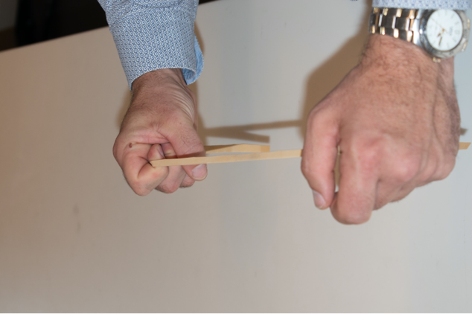Take a broad rubber band (figure 2).

Figure 2 Pitch and stretching rubber bands

Stretch it a little, make it vibrate and walk around the classroom to let students hear. Now if I stretch the rubber further, will the pitch increase, decrease, or stay the same? Stretching will increase the tension resulting in a higher pitch, but increasing length will lower the pitch. Decreasing the density per length will also lower the pitch. So the pitch will not change much and be a bit unpredictable (source and photo Wouter Spaan).

## Resonance 1

Make a pendulum of any string and an object as bob. You could even take a computer mouse suspended from electric wire. Let it swing. Give it a little push every time it reaches one of its two maxima. Resonance between push and pendulum! Or provide the little push after every two swings, or three swings, also that will be resonance which results in increasing the amplitude. Of course, a father or mother can do the same thing with a child on a swing.

## Resonance 2

Liem (1987, p300) demonstrates the principle of resonance with a pocketbook suspended from two strings like a swing (let a student hold the strings). The teacher then holds out the book at 45o with the question: “Would I be able to blow against the book until it is this far out?” The anticipated answer is “NO”. Then hang the book vertically and blow with huffs *in phase* with the swings of the book. Of course, this is just like a swing on a playground.

## In phase and out of phase

Consider the previous pendulum, one can push in phase and there is resonance and the amplitude will increase. One could also push out of phase and the pendulum motion will be disturbed and could even be stopped.

## Collisions of coins

Have two coins *A* and *B* touching and a third *C* lengthwise at a few cm distance (figure 3). Then shoot *C* towards *B* while pressing *B* down with your finger. If *A* and *B* touch, then the momentum transfers very well to coin *A* even though *B* is not able to move. The transmission mechanism must be a wave. *A* can also be put such that it is not quite in line with *CB* but still touching *B*. Also then momentum transfer takes place and A is launched under an angle6.

## Wave as propagation of a disturbance

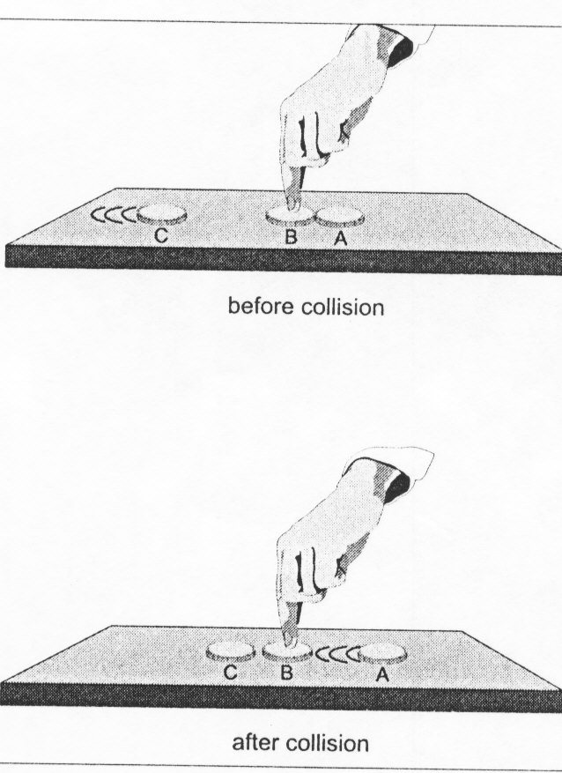

Figure 3 Impulse is being passed on from coin C through B to A even if coin B is clamped.

Get 10 students up front each at arm’s length from each other. Demonstrate a longitudinal wave by having one student at one end take a step towards his/her neighbor and back, then the next one, etc. A compression propagates. Similarly for a rarefaction. Unfortunately, this sometimes takes a little practice. So it could take 5 minutes rather than the 2 for most demo’s in this booklet. The slinky might be better, but if you forgot to bring it or if the heating of the room is insufficient and your students are a bit cold, or if the heating is too much and they are sleepy.... Of course, this way one could also simulate a transverse wave by having students in the line-up step forward or backward out of line.

## Other

If there happens to be an OHP in the room and a glass of water or Petri dish, then many demo’s on waves are possible: circular waves, reflections, or even interference by using two fingers or pencils as sources. And if there is a beamer, there are many nice video’s and simulations of wave phenomena.

## Beats, Moiré patterns

These happen when two waves or patterns interfere. For example, two combs on top of each other which have slightly different spacing between the teeth. There are spots where the spaces in between coincide (constructive interference) and spots where the tooth of one comb coincides with the space of the other (destructive interference). When you put two combs at an angle with each other (figures 4 and 5), you get nice patterns. Just borrow combs from the students. The same with lace or transparent curtains and other textiles. This also reminds us of beats for sound waves in which sounds are sometimes in phase and sometimes in opposite phase and this gives variations in the sound intensity.

|  |  |
| --- | --- |
| Afbeelding met kam, overdekt, schaar  Door AI gegenereerde inhoud is mogelijk onjuist. | Afbeelding met gereedschap, schaar, overdekt  Door AI gegenereerde inhoud is mogelijk onjuist. |
| Figure 4 Moiré patterns. The different spacing of the teeth of the combs shows some locations in phase (light) and some locations in counterphase (dark). | Figure 5 Varying the angle between the combs one can obtain all kinds of interesting patterns. |

# SOUND

## Natural sounds, frequencies, timbre

Tap against all kinds of objects to illustrate that each object has its own sound. Compare big and small wooden objects and listen to the difference in pitch (frequency). Get students to predict whether the pitch of the next object will be higher or lower. Does it have anything to do with size? Be gentle with the windows. There is more than just pitch. Sounds from tapping on wood and tapping on glass are clearly distinguishable, even if the pitch is the same. Voices of people (but also of dogs) are clearly distinguishable: timbre.

## Pitch and length 1

Borrow a ruler from a student, clamp it between one hand and the table and have part of it stick out. Now activate the oscillation with the other hand. By making the end that sticks out longer or shorter, you can vary the pitch. You can even make it quantitative by singing do-re-mi and realizing that the frequency of the second “do” is twice the frequency of the first “do”. That way you can find the relationship between length of the ruler and frequency. In order to get twice the frequency, would you have to half the length, or take length over ?

## Pitch and length 2

Take a drinking straw. Flatten the end of the straw and cut out a triangle (figure 1). Place the end of the straw in your mouth, holding your lips just where the cut ends and blow until an oboe sound is produced, shifting the straw a bit in or out of the mouth might help to get the right sound. Then while blowing, cut of small pieces of the straw. Source: Liem, 1987, p295. What did we learn? One can take another straw, cut the triangle at the end, and cut hole at 1 – 1.5 cm distance from each other (figure 1). While blowing open and close the holes with your fingers. What did we learn? Which musical instruments work like that?

## Standing waves in a PVC tube open and closed

Take two pieces of PVC pipe, for example 10 cm and 20 cm long. Blow across the opening of one pipe. It produces a clear tone. Then close the bottom opening with your hand, and blow again. The tone is now much lower, very noticeable. With both ends open, the pipe fits ½ of a wavelength (*λ=2l*). With one side closed, it fits ¼ of a wavelength (*λ=4l*). It does help to have a microphone and sound box in the room to make the effect better audible for a group. I have done it with a sound system for groups of 150+ students. FOTO

## PVC pipe length and pitch

Then take the longer pipe and show again the link between pitch and length. One could make something similar to a pan flute using pieces of PVC pipe. You could assign students the task of figuring out the proper lengths given the desired frequencies.

## Measuring pitch with a telephone

Now if you came to class to teach about sound, you would bring a little toy flute? Can students measure the pitch with their telephones?

## Mobile phone and graphing sound waves

Use Phyphox or a similar program. Try to produce a near perfect sine wave. Ask a student who sings in a choir to sing an “o”. Try a higher pitch, try a lower pitch. Try louder and less loud. Make sure not just to quickly show this on your small telephone, but sketch the graphs on the white or blackboard with clear labels. Obviously much more can be done with mobile phones and graphs. For example XXXXXX

## Resonance 1

Does somebody in class have a bottle? Some water in it yet? Or some soft drink? The instructor will drink a little bit at a time, then blow over the bottleneck to produce a sound and tick against the side of the bottle (hopefully glass). By the time the instructor gets through drinking the soft drink, one pitch has gone down consistently, the other has gone up. Now explain.

## Resonance 3

(this works with some cups and not with others) The teacher entered the classroom with a (ceramic) cup of coffee and a (metal) spoon. Hit the outside of the cup with the spoon at different places. The pitch will be different, for example near the ear of the cup, or 90 or 180 degrees away from it, under and above the level of coffee. Drink some of the coffee and repeat. How do you explain the differences in pitch and type of sound? Different resonance modes are activated as well as different lengths of the liquid column.

## vsound = f λ but velocity is independent of frequency and wave length!

Find some objects in the room, which can help you to simultaneously make a high pitch and low pitch sound and try to have students in the back judge for simultaneity of arrival of the sounds. Not so convincing? Imagine a big church or concert hall, how come choir music (try students in class) or any music at all is possible and is enjoyed by people regardless of their distance from the source? So speed of sound must be the same for all audible frequencies so that lucky we can enjoy music.

## Doppler simulation

Take 5 or 6 students and line them up in a row in front of the class. The students are wave peaks (say compressions). Now let them march as a row towards the instructor at constant speed and students can observe how many pass the instructor in say 10 seconds. Now let them march again at the same speed, but the instructor walks towards them. The instructor will meet the wave peaks in a shorter time than before and will observe a higher pitch. Repeat again but now the instructor is walking (slowly) in the same direction as the faster marching waves. The case of a moving source is more difficult to do this way but from the moving observer simulation, the students will happily accept a Doppler effect for a moving source.

# LIGHT

In the bare classroom there is scattered light from outside, sometimes direct sunlight. There are lamps in the ceiling and there are the little flashlights on the mobile telephones of students as well as light from the telephone screens. The teacher may even have a laser pointer in his/her pocket. It should be possible to show many optics phenomena with those different sources of light.

## Straight line propagation of light

The nicest start of lessons on optics is in a totally dark room with at most a candlelight. But a bare classroom is unlikely to have the necessary thick black curtains. Well, improvise with a candle, *let there be light!* I strongly suggest you go through some very basics that rarely make it into an optics lesson and try to assess some preconceptions of your students. Why not use some multiple-choice questions like the following (Osborne, 1983; Berg & Sundaru, 1989), to be answered individually. Figure 1 shows a candle burning in day light, The light of the candle: A) stays on the candle, B) comes out halfway towards you, C) moves away from the candle until obstructed. Then the same question but now the candle it is nighttime. Then follows a plenary discussion on how far light can go. If somebody with a telescope is 1 km away, can he see the candle? Does that mean that the light of the candle reaches the telescope, or is the light on the candle and the telescope looks at it?

1. Consider figure 1. A candle is burning during the day. The light from the candle:

1. stays on the candle.
2. Comes out about halfway towards you
3. Comes out as far as you but no farther
4. Comes out until it hits something.



Figure 1: You are watching a candle during the day

2. Now (Figure 2) there is a brown out during the evening and you are using a candle. The light from the candle:

1. stays on the candle.
2. Comes out about halfway towards you
3. Comes out as far as you but no farther
4. Comes out until it hits something.



Figure 2: You are watching a candle during the night



Figure 3: You are watching a lamp during the day

3. The light bulb of figure 3 is on during the day. The light from the light bulb:

1. stays on the bulb.
2. Comes out about halfway towards you
3. Comes out as far as you but no farther
4. Comes out until it hits something.

4. Now it is evening. The light from the light bulb:

1. stays on the bulb.
2. Comes out about halfway towards you
3. Comes out as far as you but no farther
4. Comes out until it hits something.

## White light and colors

Let students use transparent ballpoint pens or other transparent glass or plastic objects to produce a spectrum. Does anybody have a pocketknife with a lens? Then recombine the colors into white. With an OHP in the room there would be many more possibilities.

## Producing colors

From the previous experiment we might have learned that anything with a wedge shape, like those cheap ballpoints with a hexagonal profile, can produce colors from white light. We can recognize such shapes everywhere, like the edge of a bathroom mirror and a prism. Look around, does anybody have clothing or shoes with glitter and colors? Any wedge shapes involved?

## Color subtraction

Anybody with transparent, colored candy wrappers? Use a flashlight or the light of a telephone and shine it through the colored paper towards the students. The original light is white, the paper wrappers subtract colors from white. A red paper wrapper subtracts blue and green and lets red go through. A blue paper wrapper subtracts green and red and lets blue go through. If you have more candy wrappers and more lamps you can add colors together again (figure 4).

|  |  |
| --- | --- |
| *Afbeelding met vloer, Rechthoek, mat, Vloermateriaal  Door AI gegenereerde inhoud is mogelijk onjuist.* | Afbeelding met Kinderkunst, kunst, vakwerk, overdekt  Door AI gegenereerde inhoud is mogelijk onjuist. |
| Figure 4 Color filters for subtracting colors or use candy wrappers which students may be able to supply. | Figure 5 Spinning disks for adding colors. See the string, with one hole in the center of the disk and another off center, one can make the disk spin. |

## Color addition

Perhaps you have a Newton color disk on top of a spinning top. By spinning colors you can add them up to a white appearance. Or use a string through one hole in the center and one off center to make the disk spin. Of course PhET has a very nice simulation for color addition which shows how with primary colors all other colors can be produced.

## Reflection

There must be students in class with a mirror in their bag. Other reflecting objects might be windows, metals, spoons, etc. One can easily imagine many demonstrations. A spectacular demo is to tell your class that your whole body will be visible in any mirror as long as you increase your distance to the mirror (figures 6 and 7). Then you *disprove*, using a mirror taken from outside the classroom, or borrowing a mirror from one of the girls. Beware of convex and concave mirrors for this particular demo, the mirror should be flat.

|  |  |
| --- | --- |
|  |  |
| Figure 6 In front of the mirror. The mirror is positioned such that the person cannot see his shoes. | Figure 7 If the person walks backward, the shoes will remain invisible as the point where the reflected light ray (to the eye) hits the wall does not change. |
|  |  |
| Figure 8: Finger in glass towards front. | Figure 9 Finger in glass towards the back, we look at it through a cylindrical water lens. |
|  |  |
| Figure 10 Inverted image when the object distance is greater than the focal length. | Figure 11 Upright image if the object distance is less than the focal length. |

## FOTOSnell’s Reflection Law 1

We rarely demonstrate what it means that incident, and reflected (or refracted) light rays should be in one plane. Take three meter-sticks, or rulers, or pieces of pipe, or broom sticks, or pencils (too small). One meter-stick becomes the normal, the other two become incident and reflected or refracted rays respectively. Emphasize their orientation in one plane and show examples of orientations, which are not possible (not in one plane). Alternatively, you could ask students in their seats to demonstrate Snell’s law to you using ballpoints and pencils. You can easily check 10 students in 1 minute. If you have a laser pointer and a small mirror, then of course you could easily confirm this by putting the mirror flat on the table and shining the laser on it.

## Snell’s reflection Law 2

If there is a laser pointer in the room, then get a mirror from one of the girls, put it on the table, and show that the incoming and reflected rays are in one plane with the normal. Watch out that you get a flat mirror and not a concave or convex one.

## Snell’s reflection Law 3

If you do have pins, then you can use a pencil standing straight up and construct light rays going towards and reflected away from a vertical mirror from several viewpoints and by extension find the virtual image. See a nice series of simple and useful experiments in McDermott et al (1996, p539-561).

## Refraction 1

Walk around with pencil slanted in a glass of water, or better, in rectangular container.

## Refraction 2

Stick your finger or pencil straight up in a (round) glass of water figures 10 and 11). Move through the classroom while moving your finger forward and backward. No need for talking, many students seem surprised at this everyday observation of a “swollen” finger. Explaining can be quick by stating that the water in a glass acts as a lens. A better explanation with refraction of light rays might take 10 minutes or could be given as a task for seat or home work.

## Refraction 3 (Czech contribution to Physics on Stage, Nugent et al, 2010)

Draw parallel arrows on a piece of paper (the object), hold that behind a glass of water half-filled such that some arrows are seen through the air and other arrows through the water. If the object distance is farther than the focal length, then the arrows are reversed (figure 10). If nearer, then we see figure 11.

## Bright versus dark background

Switch off the classroom lights. The teacher or a student stands against the wall opposite of the windows. The face is clearly visible as more light is reflected from the face than from the background. Then the teacher or student stands in front of the windows with the face towards the class. Now the face looks dark and unclear as the reflected light from the face is very little compared to the light coming through the windows. Then turn on the lights in the classroom and the face is better visible again. The same effect is visible in figures 12 and 13.

## Pupil, diaphragm

Arrange students in pairs. They are to observe each other’s pupil contraction. Make the classroom dark or let students cover their eyes. Then put on the lights. Can students see each other’s pupils get smaller? Repeat one time for a better view the second time around.

|  |  |
| --- | --- |
|  |  |
| Figure 12 Tulip picture against dark background. | Figure 13 Tulip picture against light background. |

## Reflection and transmission 1

Take a piece of paper, wet it a bit in the middle with water, oil, or saliva, then hold it in front of the window (or a lamp). The wet part appears light, it transmits. Then put the paper on the table where it reflects light. Now the wet spot looks dark, because of the transmission, it reflects less than dry paper. Students can do this in their seats using their saliva or whatever wet stuff is available (figure 14).

Figure 14 Piece of paper with wet spot held against the window.

## Reflection and transmission 2

(in winter) Do students have bicycle LEDs in their pockets or bags? Darken the room. Take two LEDs. Hold the paper with the oil stain in between and look for a point where the reflection and transmission are the same. You can even make this into a light intensity meter. You can compare lamps with different power. See further: <https://www.exploratorium.edu/snacks/oil-spot-photometer>

## Accommodation of the eye

Let your students hold a pen or pencil or finger near the eye. Nearer and nearer .... the background will become unclear/unfocussed. When our eyes focus on the background, then the pen/pencil will appear unfocussed. The lens of the eye adjusts to the distance (up to a point). This is clear evidence that the lens of the eye can focus and it has to change shape and thus focal length to do so. We call this accommodation.

## Depth of field

The previous experiment also shows the camera concept of depth of field. But students can also try with their own camera’s. Let them focus on something farther away and then let them move their index finger back-and-forth in front of the lens. See how the background is sharp and the finger in the foreground is not. Also try with written words in the foreground and background. The camera’s nowadays have a surprising depth of field. Perhaps have some example photographs ready on the beamer in your classroom.

## Lenses

Investigate spectacle lenses of students. Use the window as object (or a bicycle LED) and a piece of paper or the wall opposite the windows as screen. Look at concave and convex lenses in spectacles, see whether the image is reversed or not, etc.

## Narrow slit diffraction or refraction?

Look at the lights in the ceiling, close your eyes to a narrow slit, the beam widens perpendicular to the direction of the slit. The effect is better when using an incandescent light bulb up front, preferably with transparent glass and a straight filament. Could Huygens have seen this evidence of diffraction in the 17th century? Well, try tonight with a candle. With some lights even color fringes are clearly visible. However, the famous Minnaert (1954) explained the stripes of light through differential *refraction* by little dykes of liquid along the edge of the eyelid (part 1, p122 of the original Dutch edition). So no refraction after all. But now pay attention to light falling through your eyelashes. Do you see colors? Now isn’t that diffraction by hairs?

## Mouche volante

There is more to see in the eye itself. Look into the beautiful blue sky or another even light background like a white classroom ceiling and you may see wiry structures floating in your eye. See <http://en.wikipedia.org/wiki/entoptic_phenomenon> for a better description and some other phenomena in our eyes. While turning your head, these wiry structures tend to stay behind: inertia and proof that these are structures floating in the liquid in the eyes!

## Parallax

Have students close their right eye and stick up their pen at arm’s length such that it is in line with a mark on the black board. Have them then close the right eye and open the left one. The pen is no longer in line with the mark on the board as we look at it from just a different angle. That is parallax. The farther the distance from pen to the ark on the board, the smaller the difference. So parallax can be used for distance measurement. See figure X REFER TO EMBALZADO DRAWING for explanation and see figures 15 and 16 for the apparent shift of the pen against a background.

|  |  |
| --- | --- |
|  |  |
| *Figure 15 The pen at arms’ length from the camera (the eye), is exactly aligned with the edge of the batik.* | *Figure16 The camera has been shifted 5 cm to the left which is the distance between the eyes. The pen did not shift. The closer the pen from the batik, the smaller the apparent shift in position.* |

## Dominance of one eye

With two eyes open keep the pen at arm’s length and aligned with a mark on the board, focus the eyes on the board. Now close the left eye, then open left and close the right eye. If the pen shifts quite a bit (compared to two eyes open) when the right eye is closed, then the right eye is the dominant one. If that does not happen for the right eye, but for the left eye, then the left eye is dominant.

## Seeing depth 1

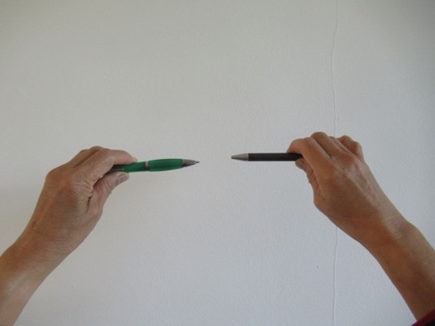Two eyes are better than one, especially in seeing depth and estimating distances. Let students take a pen or pencil in the left hand and another one in the right hand (figure 20). Move both hands around a bit and then let all student close one eye and move the pens toward one another until the tips touch. With one eye closed that is difficult, with two eyes open it is easy. The experiment can also be done with the two index fingers, but with pens it is more dramatic.

Figure 17 Estimating distance with one or two eyes.

## Seeing depth 2

This demonstration can be done as a teacher demonstration with a student in front of the class but can also be done as a semi-lab activity with student pairs where in each group one student is subject and the other is experimenter. Collect coins or buttons or paper clips or other small objects and a beaker (or draw a circle on paper). The beaker or circle should be about 60 cm from the subject. The subject closes one eye. The teacher or student experimenter holds a coin or button about 50 cm above the table and moves the hand slowly. The subject says “drop” when (s)he thinks the object is exactly above the target and then see whether the object falls inside the beaker or circle. Compare greater and smaller distances and one or two eyes. An alternative with more clear reports is to draw concentric circles with a radius of 1, 2, and 5 cm. The subject is located 1,5 m from the circles with one eye closed. The experimenter holds a marker with the tip downward. The subject instructs the experimenter to move the marker forward/backward or left/right until (s)he thinks the marker is above target. Then drop. The pattern of dots constitutes the report. Use different color markers for different conditions such as one or two eyes closed or different distances, or different observers.

## Blind spot

Almost any textbook has instructions for how to find the blind spot of the eye. Copy the set-up from a picture in the book onto the blackboard. check

## Center and sides of retina, peripheral vision

Think of something to illustrate the different nature of eye cells in the center and at the periphery of the retina. The periphery is much more sensitive, protecting eyes against insects, etc. Students will volunteer their stories. UNCLEAR

## Optical illusions

Photocopy the famous pictures of parallel lines which do not seem parallel, Escher’s art work, Gestalt pictures, etc. onto transparencies and that are ten little demo’s right there. Or google on optical illusions and put them on your classroom beamer <http://www.optics4kids.org/home/content/illusions/)>.

## Diffraction

If you or your classroom is equipped with a laser pointer, then possibilities for experiments are endless: hairs, holes, slits, reflection, refraction, diffraction, scattering from dust.

## OHP

If there is an OHP in the room, then 10 or 20 short demos could easily be added to this list. Think of the typical blue-purple or red-orange fringes around shadows of objects between lens and screen. One can create similar fringes by looking at windows or door openings through a big prism containing water. When the prism’s triangle is pointing up, the red-yellow occurs above shades and the bluish-purple below shades. Turning the prism upside down gives the opposite effect. This is the key to explanation.

## Minnaert

Marcel Minnaert was a well-known Flemish - Dutch astronomer who wrote a famous series of three books on physics in the environment. His book on light and color in the landscape was translated in English and appeared in 1954 (Minnaert, 1954). He describes many simple experiments that he conducted with almost no tools and often surprising results. Check your knowledge of Physics in the environment against Minnaert’s observations!

## Other

See Wojewoda (2017) for simple optics experiments with a laser or laser pointer.

# MODERN PHYSICS

## Flames and colors

Try a candle, what colors do you see? Try some alcohol, since the pandemic quite abundant. What color is the flame? Now add some salt to the alcohol. What color do you see now (more orange and better visible, sodium!). All elements have their own spectral lines, Sodium has the famous yellow/orang lines. Some other salts available?

MODERN PHYSICS VISUALIZATIONS

Physicists like the surprise element in modern physics experiments, but to experience the surprise, one has to have expectations based on prior knowledge of traditional physics. Many students do not have that and take the outcomes of the experiment for granted without surprise or interest. Therefore, the teacher has to prepare the students carefully for the experiment. Following are some visualizations which might help.

## Particle-wave duality

Before presenting particle-wave duality, the teacher should contrast the classical differences between particles and waves. Take a glass of water or –if available- a basin. Make a wave. Where is the wave in the basin? Everywhere! The teacher talks, where is the sound? Everywhere! We cannot localize a wave, it is everywhere. Now take a piece of chalk or a pen or pencil, or a coin. Where is it? There are sharp boundaries for any object, objects are localized. This is the essential difference between waves and matter/particles. Then proceed to duality. Hopefully you have a beamer with PhET simulations or [www.falsted.com](http://www.falsted.com).

## Double slit, role play of how it is NOT

Imagine the situation of shooting microscopic bullets through a double slit. That can be simulated in a roleplay. Make two narrow slits by arranging tables and use the wall of the classroom as screen. Send students through the slits, they are only allowed straight lines and so they end up in two clumps on the screen. They form an image of the slit. If you send them one by one, this image builds up gradually. That is what you expect with particles. However, if the bullets were electrons, or protons, or even bigger molecules like C60 (buckeyball), then it is NOT like that. While the electron or proton or C60 is on its way, we do not know where it is. We do not even know through which slit it goes. The particle might be everywhere during its travel, but it does end up at a particular spot on the screen and that spot might not be in a straight line behind the slit. Eventually all these spots together form an interference pattern typical for waves. Electrons, protons and molecules *propagate* like waves but are *absorbed* and *emitted* like particles. Also show some simulations. There are many versions of the double slit experiment, for example with detectors at the slit(s), or even so called delayed choice experiments. Ananthaswamy (2018) wrote a captivating and very readable book about this famous class of experiments.

## Mass numbers of the elements

The fact that mass numbers of elements are not integers is difficult to understand. The non-integer mass numbers are a result of averaging masses of isotopes and mass deficits due to bonding. Get some students up front, for example, 4 single students (4 protons) and one pair (a deuterium nucleus consisting of a proton and a neutron). If indeed one out of 5 Hydrogen atoms would be Deuterium, then the mass number would be about 1.2. However, the mass number is about 1.008 showing that less than 1 in 100 Hydrogen atoms is Deuterium and the rest single protons. Atomic mass is an average of the masses of many atoms of a single element including the naturally occurring isotopes.

## Rutherford experiment

Rutherford scattering is difficult to visualize for students. Let one student in the classroom (=the atom) hold up a bag…the Gold nucleus. Then the instructor (or a student) takes some small pieces of chalk and is blindfolded (or closes the eyes). From random positions in front of the class the instructor throws electrons in the general direction of the back of the class. The chances that the chalk hits the bag are relatively small. The smaller the bag, the smaller the number of hits. So the number of chalks being bounced back says something about the size of the bag. In Rutherford’s experiment, very few electrons are bounced back meaning that the nucleus only occupies a very small part of the atom. Actually, Rutherford had expected a large and soft nucleus so all electrons would get kind of stuck inside and none would bounce back. So he commented “as if you shoot bullets at a piece of paper and some bounce back!”

## Big bang and Hubble 1

Govert Schilling (2017, p167) compares the cosmos with a raisin cake. The raisins form the corners of a system of cubes in which each cube is 1 x 1 x 1 cm. When the dough rises so that after one hour the distance between neighboring raisins is 2 cm, then each cube is 2 x 2 x 2 cm. Suppose you sit on a raisin, then you see the nearest raisin move away from you with a speed of 1 cm/hour. However, the next raising is now at 4 cm instead of the initial 2 cm, so that one moved 2 cm/hour. This could also be done in a roleplay, positioning students in a matrix.

## Big bang and Hubble 2

A very easy way to show this multiplication of distances is to line up 4 students at 1 meter distance from each other. Then the distance from number 1 to number 2 doubles to two meters. Let students compute what the distances between 2 and 3 and 3 and 4 should become. Numbers 3 and 4 also have to move along with that and do this one meter step. But number 3 also has to take the extra step which #4 has to follow. And then #4 has to take the extra step yet. So now the distances between 1, 2, 3, 4 are 2m, 4m, and 8m. It is very instructive to see this.

## Big bang and Hubble 2

Often cosmic expansion is shown with a balloon. Blow a balloon a little bit and mark some points. Then blow it up more and the points will get farther away from each other. We should really look only at what happens at the surface of the balloon and not at three dimensions. The pitfall is that students will see this 3-dimensionally as expansion from one particular point.

## Hidden dimensions in string theory

Some theories of space-time such as in string theories propose more than 3 (space) or 4 (space-time) dimensions. In one of his videos Sean Carroll uses a visualization to show how one could not see a dimension. A sheet of A4 has 2 dimensions, length and breadth. When rolled up tight the two dimensions are still there, but one is invisible.

And there are many more possibilities of experiments with no equipment. Google on freihandversuche for German literature (use Google translate) or look in Minnaert(1954) or see the 400+ demonstrations in Liem(1987) many of which can be performed without specialized equipment. Freihandversuche only require very simple equipment, but it might be just a bit more than what you typically have in your pocket.

# LITERATURE

Ananthaswamy, A. (2018). Through two doors at once. The elegant experiment that captures the enigma of our quantum reality. New York: DUTTON Penguin Random House.

Berg, E. van den, Sundaru. (1990). Student ideas on the velocity of light. *The Australian Science Teachers Journal*, *36*(2), 72-75, (May 1990). A diagnostic test in English on the propagation of light is available from the first author.

Berg, E. van den, Grosheide, W. (1997). Learning and teaching about energy, power, current, and voltage. *School Science Review*, March 1997, 78(284), 89-94.

Berg, E and R van den, N. Capistrano, A. Sicam (2000). Kinematics graphs and instant feedback. *School Science Review*, 82(299), 104-106.

Berg, E. van den (2000). Role-playing in Astronomy. *School Science Review*, 81(296), 125-129.

Berg, E. van den (2021). Workshop demonstrations with almost nothing: Thirty examples with a glass of water. IOP Journal of Physics Conference Series Volume **1929** 012068. Proceedings of the GIREP 2019 Conference in Budapest. <https://iopscience.iop.org/article/10.1088/1742-6596/1929/1/012068>

Culaba, I, Berg, E. van den (2009). Shear stress and tensile stress. The Physics Teacher, 47, 121.

Ehrlig, R. (1994). “Ruler physics”, thirty-four demonstrations using a plastic ruler. *American Journal of Physics*, 62(2), 111-120.

Frederik, J. et al (2015). Showdefysica, fysica laat je zien. Meppel: NVON.

Frederik, J. et al (2017). Showdefysica, fysica laat je zien II. Meppel: NVON.

Goldberg, F. XXXXX

Hammack, W.S., DeCoste, D.J. (2016). Michael Faraday’s The Chemical History of a Candle. With Guides to Lectures, Teaching Guides, & Student Activities. Articulate Noise Books, Urbana, Illinois. <https://engineerguy.com/faraday/pdf/faraday-chemical-history-complete.pdf>

Hewitt, P. (2015). *Conceptual Physics* (12h edition). Addison-Wesley.

Liem, T.K. (1987). *Invitations to Science Inquiry*. Science Inquiry Enterprises. 14358 Village View Lane, Chino Hills, California 91709.

Marlow, A.R. (1991). A surprising mechanics demonstration. American Journal of Physics, 59(10), 951.

McDermott, L.C., Shaffer, P.S., Rosenquist, R.L. (1996). Physics by Inquiry Volume II. New York: Wiley.

Minnaert, M. (1954). The nature of light & color in the open air. New York: Dover Publications.

Nugent, P. et al (2010). Physics on Stage 2 & 3 Demonstrations and teaching ideas selected by the Irish teams. Dublin: Dublin City University.

Schilling, G. XXXXX

Sefton, I. (2002). Understanding electricity and circuits, what textbooks do not tell you. <http://science.uniserve.edu.au/school/curric/stage6/phys/stw2002/sefton.pdf>

Subagyo, Berg, E. van den, (1992). Coins, waves, and money. *The Physics Teacher, 30*(8), 509.

Weltner. K. (1990a). Aerodynamic lifting force. *The Physics Teacher*, 28(2), 78-82.

Weltner. K. (1990b). Bernoulli’s law and aerodynamic lifting force. *The Physics Teacher*, 28(2), 84-86.

Wojewoda, G. (2017). <http://www.pl.euhou.net/docupload/files/Excersises/WorldAroundUs/Diffraction/Diffraction_and_Interference_v2.pdf>. Accessed 10 July 2017.

[*https://www.youtube.com/watch?v=xbafUQto5uk*](https://www.youtube.com/watch?v=xbafUQto5uk)

1. Suggestions for Biology and Chemistry can be found in Appendix A and Appendix B.
2. A few of the demonstrations were published in *The Physics Teacher* (USA), September 1998, Vol 36, 356-358. Some others were published in various national and international conference proceedings.